UNITED STATES
SECURITIES AND EXCHANGE COMMISSION
Washington, DC 20549
FORM 8-K
​
​
CURRENT REPORT
Pursuant to Section 13 or 15(d)
of the Securities Exchange Act of 1934
​
Date of Report (Date of earliest event reported): October 22, 2026
​
​
​
ALPINE INCOME PROPERTY TRUST, INC.
(Exact name of registrant as specified in its charter)

​ | ​  ​  ​ | ​
Maryland | Commission File Number 001-39143 | 84-2769895
(State or other jurisdiction of  incorporation or organization) | ​ | (I.R.S. Employer  Identification No.)
​
​

​  ​ | ​
369 N. New York Avenue, Suite 201  Winter Park, Florida | 32789
(Address of principal executive offices) | (Zip Code)
​
Registrant’s Telephone Number, including area code
(407) 904-3324
​
Check the appropriate box below if the Form 8-K filing is intended to simultaneously satisfy the filing obligation of the registrant under any of the following provisions:
​

​ | ​
☐ | Written communications pursuant to Rule 425 under the Securities Act (17 CFR 230.425)
☐ | Soliciting material pursuant to Rule 14a-12 under the Exchange Act (17 CFR 240.14a-12)
☐ | Pre-commencement communications pursuant to Rule 14d-2(b) under the Exchange Act (17 CFR 240.14d-2(b))
☐ | Pre-commencement communications pursuant to Rule 13e-4(c) under the Exchange Act (17 CFR 240.13e-4(c))
​
​
​
​
​
Securities Registered Pursuant to Section 12(b) of the Act
​

​ | ​ | ​
Title of each class | Trading Symbol | Name of each exchange on which registered
Common Stock, $0.01 Par Value | PINE | NYSE
​ | ​ | ​
8.000% Series A Cumulative Redeemable Preferred Stock, $0.01 Par Value | PINE/PA | NYSE
​
Indicate by check mark whether the registrant is an emerging growth company as defined in Rule 405 of the Securities Act of 1933 (§230.405 of this chapter) or Rule 12b-2 of the Securities Exchange Act of 1934 (§240.12b-2 of this chapter).
Emerging growth company ☐
If an emerging growth company, indicate by check mark if the registrant has elected not to use the extended transition period for complying with any new or revised financial accounting standards provided pursuant to Section 13(a) of the Exchange Act. ☐
​
​
Item 2.02. Results of Operations and Financial Condition
​
On October 22, 2026, Alpine Income Property Trust, Inc., a Maryland corporation (the "Company"), issued an earnings press release and an investor presentation relating to the Company’s financial results for the quarter and nine months ended September 30, 2026. Copies of the press release and investor presentation are attached hereto as Exhibits 99.1 and 99.2, respectively, and are incorporated herein by reference.
​
The information in Item 2.02 of this Current Report, including Exhibits 99.1 and 99.2 is being furnished and shall not be deemed “filed” for purposes of Section 18 of the Securities Exchange Act of 1934, as amended (the “Exchange Act”), or otherwise subject to the liabilities of that Section. The information in this Current Report shall not be incorporated by reference into any registration statement or other document pursuant to the Securities Act of 1933, as amended (the “Securities Act”), or the Exchange Act, unless it is specifically incorporated by reference therein.
​
Item 7.01. Regulation FD Disclosure
​
On October 22, 2026, the Company issued an earnings press release and an investor presentation relating to the Company’s financial results for the quarter and nine months ended September 30, 2026. Copies of the press release and investor presentation are attached hereto as Exhibits 99.1 and 99.2, respectively, and are incorporated herein by reference.
​
The furnishing of these materials is not intended to constitute a representation that such furnishing is required by Regulation FD or other securities laws, or that the materials include material investor information that is not otherwise publicly available. In addition, the Company does not assume any obligation to update such information in the future.
​
The information in Item 7.01 of this Current Report, including Exhibits 99.1 and 99.2 is being furnished and shall not be deemed to be “filed” for purposes of Section 18 of the Exchange Act or otherwise subject to the liabilities of that Section. The information in this Current Report shall not be incorporated by reference into any registration statement or other document pursuant to the Securities Act or the Exchange Act, unless it is specifically incorporated by reference therein.
​
Item 9.01. Financial Statements and Exhibits
​
(d) Exhibits
​
99.1 Earnings Press Release dated October 22, 2026
99.2 Investor Presentation dated October 22, 2026
104 Cover Page Interactive Data File (embedded within the Inline XBRL document)
​
SIGNATURES
Pursuant to the requirements of the Securities Exchange Act of 1934, the registrant has duly caused this report to be signed on its behalf by the undersigned hereunto duly authorized.
​
Date: October 22, 2026
​
Alpine Income Property Trust, Inc.
​
By: /s/ Philip R. Mays
Senior Vice President, Chief Financial Officer and Treasurer
(Principal Financial Officer)
Exhibit 99.1
​
​

​
Press Release
​
​
​
​  ​  ​ | QUARTER 2024 OPERATING RESULTS  ​
FOR  IMMEDIATE  RELEASE | ALPINE INCOME PROPERTY TRUST REPORTS  THIRD QUARTER 2026 OPERATING AND  FINANCIAL RESULTS  ​  – Record of Over $300 Million of Investment Activity Completed and Under-Contract Year-to-Date –  – 2026 AFFO per Diluted Share Guidance Increased to $2.20 - $2.22 –  ​
​
WINTER PARK, FL – October 22, 2026 – Alpine Income Property Trust, Inc. (NYSE: PINE) (the “Company” or “PINE”), an owner and operator of single tenant net leased commercial income properties, today announced its operating results and earnings for the three and nine months ended September 30, 2026.
​
Third Quarter 2026 Highlights
​
Operating results for the three and nine months ended September 30, 2026 and 2025 (dollars in thousands, except per share data):
​
​ | ​ | ​ | ​ | ​ | ​ | ​ | ​ | ​ | ​ | ​ | ​ | ​
​ |  | Three Months Ended  September 30, |  |  |  |  | ​ | Nine Months Ended  September 30,
​ | ​ | 2026 |  | ​ | 2025 |  | ​ | 2026 |  | ​ | 2025
Total Revenues | ​ | $ | 20,460 | ​ | $ | 14,563 | ​ | $ | 58,868 | ​ | $ | 43,632
Net Income (Loss) Attributable to Common Stockholders | ​ | $ | 3,443 | ​ | $ | (1,310) | ​ | $ | 7,510 | ​ | $ | (4,130)
Net Income (Loss) per Diluted Share Attributable to Common Stockholders | ​ | $ | 0.18 | ​ | $ | (0.09) | ​ | $ | 0.42 | ​ | $ | (0.29)
FFO Attributable to Common Stockholders (1) | ​ | $ | 10,356 | ​ | $ | 7,135 | ​ | $ | 29,704 | ​ | $ | 20,832
FFO Attributable to Common Stockholders per Diluted Share (1) | ​ | $ | 0.55 | ​ | $ | 0.46 | ​ | $ | 1.65 | ​ | $ | 1.34
AFFO Attributable to Common Stockholders (1) | ​ | $ | 10,423 | ​ | $ | 7,128 | ​ | $ | 29,886 | ​ | $ | 20,909
AFFO Attributable to Common Stockholders per Diluted Share (1) | ​ | $ | 0.55 | ​ | $ | 0.46 | ​ | $ | 1.66 | ​ | $ | 1.34

 | (1) | See the “Non-GAAP Financial Measures” section and tables at the end of this press release for a discussion and reconciliation of Net Income (Loss) to non-GAAP financial measures.
​
“We continued to execute on our growth strategy in the third quarter, investing nearly $41 million at an attractive weighted average initial cash yield of 8.5%," said John P. Albright, President and Chief Executive Officer of Alpine Income Property Trust. "Including our pending $117.3 million portfolio acquisition, our closed and under-contract investment activity year-to-date exceeds $300 million, a Company record that surpasses our full-year 2025 total of $278 million. Given this strong investment activity and the continued performance of our portfolio we are raising our full-year 2026 guidance.”
Page 1
​

Investment Activity
​
Investments for the three and nine months ended September 30, 2026 (dollars in thousands):
​
​ | ​ | ​ | ​ | ​ | ​ | ​ | ​ | ​ | ​ | ​ | ​ | ​
​ | ​ | Three Months Ended September 30, 2026 |  |  |  |  | ​ | Nine Months Ended September 30, 2026
​ | ​ | Number of Investments |  | ​ | Amount |  | ​ | Number of Investments |  | ​ | Amount
Properties (1) | ​ | ​ | 3 | ​ | $ | 39,210 | ​ | ​ | 7 | ​ | $ | 85,785
Commercial Loan Originations | ​ | ​ | 1 | ​ | ​ | 1,720 | ​ | ​ | 5 | ​ | ​ | 105,650
Total Investments | ​ | ​ | 4 | ​ | $ | 40,930 | ​ | ​ | 12 | ​ | $ | 191,435
​ | ​ | ​ | ​ | ​ | ​ | ​ | ​ | ​ | ​ | ​ | ​ | ​
Properties - Weighted Average Initial Cash Cap Rate | ​ | ​ | ​ | ​ | ​ | 8.5% | ​ | ​ | ​ | ​ | ​ | 8.0%
Commercial Loans - Weighted Average Initial Coupon Rate (2) | ​ | ​ | ​ | ​ | ​ | 10.0% | ​ | ​ | ​ | ​ | ​ | 13.0%
Total Investments - Weighted Average Initial Yield | ​ | ​ | ​ | ​ | ​ | 8.5% | ​ | ​ | ​ | ​ | ​ | 10.8%
Properties - Weighted Average Remaining Lease Term at Time of Acquisition | ​ | ​ | 4.3 years |  |  |  | ​ | ​ | 13.4 years

 | (1) | The nine months ended September 30, 2026 investments include $26.3 million of property acquisitions that are accounted for as financing arrangements for GAAP purposes and are included in the Sale-Leaseback and Sales-Type Lease Properties, hereinafter defined.
 | (2) | Includes paid-in-kind (“PIK”) interest coupon rate.
​
​
Pending Portfolio Acquisition and New Debt Financing
​
On October 9, 2026, the Company announced an agreement to acquire a 13-property industrial portfolio for $117.3 million, or $63 per square foot. The portfolio totals approximately 1.9 million square feet across 11 states and is 100% leased to nine tenants under absolute triple-net leases with annual rent escalations. The leases have a weighted average remaining lease term of 10.2 years, with no lease expirations before late 2031. The acquisition is expected to close in the fourth quarter of 2026, subject to customary closing conditions.
​
Subsequent to quarter end, the Company received bank commitments for a new $100 million four-year term loan and a $75 million increase in commitments under its revolving credit facility, to $325 million from $250 million. The new financing will increase the Company's potential liquidity by $175 million, providing additional capacity to fund pending and future acquisitions.The new financing is expected to close in late October 2026, and the term loan proceeds will be used to repay outstanding revolving credit facility borrowings.
​
​
Disposition Activity
​
Dispositions for the three and nine months ended September 30, 2026 (dollars in thousands):
​
​ | ​ | ​ | ​ | ​ | ​ | ​ | ​ | ​ | ​ | ​ | ​ | ​
​ | ​ | Three Months Ended September 30, 2026 |  |  |  |  | ​ | Nine Months Ended September 30, 2026
​ | ​ | Number of Investments |  | ​ | Amount |  | ​ | Number of Investments |  | ​ | Amount
Properties | ​ | ​ | — | ​ | $ | — | ​ | ​ | 3 | ​ | $ | 5,816
Properties (Vacant) | ​ | ​ | 1 | ​ | ​ | 410 | ​ | ​ | 1 | ​ | ​ | 410
Commercial Loans | ​ | ​ | — | ​ | ​ | — | ​ | ​ | 1 | ​ | ​ | 10,763
Total Dispositions | ​ | ​ | 1 | ​ | $ | 410 | ​ | ​ | 5 | ​ | $ | 16,989
​ | ​ | ​ | ​ | ​ | ​ | ​ | ​ | ​ | ​ | ​ | ​ | ​
Properties - Weighted Average Exit Cash Cap Rate | ​ | ​ | ​ | ​ | ​ | — % | ​ | ​ | ​ | ​ | ​ | 7.4%
Commercial Loans - Weighted Average Cash Yield | ​ | ​ | ​ | ​ | ​ | — % | ​ | ​ | ​ | ​ | ​ | 10.0%
Total Dispositions - Weighted Average Cash Yield | ​ | ​ | ​ | ​ | ​ | — % | ​ | ​ | ​ | ​ | ​ | 9.1%
​
Page 2
​

Investments
​
The Company’s property and commercial loan portfolios consisted of the following as of September 30, 2026:
​ | ​ | ​
Property Portfolio | ​ | ​
Number of Properties | ​ | 130
Square Feet | ​ | 4.8 million
Annualized Base Rent (ABR) (1) | ​ | $53.9 million
Weighted Average Remaining Lease Term | ​ | 8.7 years
States where Properties are Located | ​ | 31
Industries | ​ | 25
Occupancy | ​ | 99.6%
​ | ​ | ​
% of ABR Attributable to Investment Grade Rated Tenants | ​ | 56%
% of ABR Attributable to Credit Rated Tenants | ​ | 68%
% of ABR Attributable to Sale-Leaseback and Sales-Type Lease Properties (2) | ​ | 12%
​ | ​ | ​
Commercial Loan Portfolio (3) | ​ | ​
Number of Commercial Loans | ​ | 11
Outstanding Face Amount (4) | ​ | $160.1 million
Weighted Average Coupon Rate (5) | ​ | 13.4%
Weighted Average Remaining Term | ​ | 1.4 years
Unfunded Commitment Amount | ​ | $75.5 million

 | (1) | ABR represents annualized in-place straight-line base rent pursuant to GAAP. Annualized in-place cash base rent totaled $51.8 million.
 | (2) | The Company owns four single-tenant income properties which were acquired through sale-leaseback transactions that include tenant repurchase options and one single-tenant income property which qualifies as a sales-type lease (collectively, the "Sale-Leaseback and Sales-Type Lease Properties"). These Sale-Leaseback and Sales-Type Lease Properties are accounted for as financing arrangements for GAAP purposes. However, as they constitute real estate assets for both legal and tax purposes, we include them for purposes of describing our property portfolio, including for tenant, industry, and state concentrations and exclude them for purposes of describing our commercial loan portfolio. The Sale-Leaseback and Sales-Type Lease Properties represent 10.0% of annualized in-place cash base rent.
 | (3) | See Supplemental Disclosure on Commercial Loans and Investments on page 14 of this press release.
 | (4) | Net of $18.5 million A-1 Participation and $57.2 million of financing related to Sale-Leaseback and Sales-Type Lease Properties.
 | (5) | Includes PIK interest coupon rate.
​
The Company’s property portfolio included the following top tenants that represent 2.0% or greater of the Company's total ABR as of September 30, 2026:
​ | ​ | ​ | ​ | ​
Tenant | ​ | Credit Rating | ​ | % of ABR
Lowe's | ​ | BBB+ / Baa1 | ​ | 14%
Dick's Sporting Goods | ​ | BBB / Baa2 | ​ | 10%
Beachside Hospitality Group | ​ | NR / NR | ​ | 7%
Walmart | ​ | AA / Aa2 | ​ | 6%
Best Buy | ​ | BBB+ / A3 | ​ | 6%
Alamo Drafthouse | ​ | A+ / A2 | ​ | 5%
Dollar General | ​ | BBB / Baa3 | ​ | 4%
Family Dollar | ​ | NR / NR | ​ | 4%
GermFree Laboratories | ​ | NR / NR | ​ | 4%
Walgreens | ​ | NR / NR | ​ | 3%
At Home | ​ | NR / NR | ​ | 3%
Bass Pro Shops | ​ | BB- / Ba3 | ​ | 3%
BJ's Wholesale Club | ​ | BB+ / Ba1 | ​ | 2%
Academy Sports | ​ | BB+ / Ba2 | ​ | 2%
Dollar Tree | ​ | BBB / Baa2 | ​ | 2%
TJX Companies | ​ | A / A2 | ​ | 2%
Aspen Retail | ​ | NR / NR | ​ | 2%
Other | ​ | ​ | ​ | 21%
Total | ​ | ​ | ​ | 100%
Page 3
​

The Company’s property portfolio consisted of the following top industries that represent 2.0% or greater of the Company's total ABR as of September 30, 2026:
​ | ​ | ​
Industry | ​ | % of ABR
Home Improvement | ​ | 16%
Sporting Goods | ​ | 15%
Casual Dining | ​ | 10%
Dollar Stores | ​ | 10%
Entertainment | ​ | 7%
Grocery | ​ | 7%
Consumer Electronics | ​ | 6%
Home Furnishings | ​ | 6%
Pharmacy | ​ | 4%
Off-Price Retail | ​ | 4%
Technology, Media & Life Sciences | ​ | 4%
Wholesale Club | ​ | 2%
Other | ​ | 9%
​ Total | ​ | 100%
​
​
The Company’s property portfolio included properties in the following top states that represent 2.0% or greater of the Company’s total ABR as of September 30, 2026:
​ | ​ | ​
State | ​ | % of ABR
Florida | ​ | 11%
Texas | ​ | 10%
North Carolina | ​ | 9%
New Jersey | ​ | 8%
Colorado | ​ | 7%
Virginia | ​ | 6%
New York | ​ | 6%
Michigan | ​ | 6%
Illinois | ​ | 5%
Georgia | ​ | 3%
Ohio | ​ | 3%
Minnesota | ​ | 3%
West Virginia | ​ | 3%
Tennessee | ​ | 3%
Wisconsin | ​ | 2%
Kansas | ​ | 2%
Louisiana | ​ | 2%
Oklahoma | ​ | 2%
Other | ​ | 9%
​ Total | ​ | 100%
​
​
Page 4
​

Balance Sheet and Capital Markets
​
​ | ​ | ​
(Dollars in table in thousands) | As of September 30, 2026
Leverage | ​ | ​
Net Debt / Total Enterprise Value | ​ | 49.5%
Net Debt / Pro Forma Adjusted EBITDA | ​ | 6.5x
Fixed Charge Coverage Ratio | ​ | 3.1x
​ | ​ | ​
Liquidity | ​ | ​
Available Capacity Under Revolving Credit Facility | $ | 51,500
Cash and Cash Equivalents | ​ | 11,722
Total Liquidity | $ | 63,222
​
​
As of September 30, 2026, the Company had $198.5 million outstanding under its Revolving Credit Facility, which had total commitments of $250.0 million. Borrowing availability under the Revolving Credit Facility is based on unencumbered asset value, as defined in the underlying credit agreement, and as of September 30, 2026, the Company had $51.5 million of additional borrowing availability. As discussed above, subsequent to quarter end, the Company received bank commitments for $175.0 million of new financing, consisting of a $100.0 million term loan and a $75.0 million increase in Revolving Credit Facility commitments, which is expected to close in late October 2026 and increases potential liquidity by $175.0 million.
​
During the three months ended September 30, 2026, the Company issued 335,457 common shares under its common stock ATM offering program at a weighted average gross price of $20.01 per share, for total net proceeds of $6.6 million. During the three months ended September 30, 2026, the Company issued 63,879 preferred shares under its Series A Preferred Stock ATM offering program at a weighted average gross price of $25.22 per share, for total net proceeds of $1.6 million.
​
During the nine months ended September 30, 2026, the Company issued 3,136,532 common shares under its common stock ATM offering program at a weighted average gross price of $19.38 per share, for total net proceeds of $59.9 million. During the nine months ended September 30, 2026, the Company issued 406,419 preferred shares under its Series A Preferred Stock ATM offering program at a weighted average gross price of $25.18 per share, for total net proceeds of $10.0 million.
​
​
Page 5
​

The Company’s long-term debt as of September 30, 2026 (dollars in thousands):
​
​ | ​ | ​ | ​ | ​ | ​ | ​ | ​ | ​ | ​
​ | ​ | As of September 30, 2026
​ | ​ | Face Value Debt |  | ​ | Stated Interest Rate | ​ | Wtd. Avg. Rate | ​ | Maturity Date
Revolving Credit Facility (1) | ​ | $ | 198,500 | ​ | SOFR +  [1.25% - 2.20%] | ​ | 4.96% | ​ | February 2030
2029 Term Loan (2) | ​ | ​ | 100,000 | ​ | SOFR +  [1.25% - 1.90%] | ​ | 4.66% | ​ | February 2029
2031 Term Loan (3) | ​ | ​ | 100,000 | ​ | SOFR +  [1.25% - 1.90%] | ​ | 3.35% | ​ | February 2031
Total Debt/Weighted-Average Rate | ​ | $ | 398,500 | ​ | ​ | ​ | 4.48% | ​ | ​

 | (1) | As of September 30, 2026, the Company has utilized interest rate swaps to fix SOFR and achieve a weighted average fixed interest rate of 3.32% plus the applicable spread on $100 million of the outstanding balance on the Company’s Revolving Credit Facility.
 | (2) | As of September 30, 2026, the Company has utilized interest rate swaps to fix SOFR and achieve a weighted average fixed interest rate of 3.36% plus the applicable spread for the $100 million 2029 Term Loan balance.
 | (3) | As of September 30, 2026, the Company has utilized interest rate swaps to fix SOFR and achieve a weighted average fixed interest rate of 2.05% plus the applicable spread for the $100 million 2031 Term Loan balance.
​
As of September 30, 2026, the Company held a 93.6% common interest in Alpine Income Property OP, LP, the Company’s operating partnership (the “Operating Partnership” or “OP”). There were 1,223,854 common OP Units held by third parties outstanding and 17,935,407 shares of the Company’s common stock outstanding for a combined total of 19,159,261 shares of common stock and common OP Units held by third parties as of September 30, 2026.
​
Dividends
The Company’s dividends for the three and nine months ended September 30, 2026:
​
​ | ​ | ​ | ​ | ​ | ​
​ | Three Months Ended  September 30, 2026 |  | ​ | Nine Months Ended  September 30, 2026
Preferred Dividends Declared and Paid per Share | $ | 0.500 | ​ | $ | 1.500
Common Dividends Declared and Paid per Share | $ | 0.320 | ​ | $ | 0.920
FFO Attributable to Common Stockholders Payout Ratio | ​ | 58.2% | ​ | ​ | 55.8%
AFFO Attributable to Common Stockholders Payout Ratio | ​ | 58.2% | ​ | ​ | 55.4%
​
2026 Outlook
The Company is revising its 2026 outlook. The Company’s 2026 guidance is based on current plans and a number of assumptions and is subject to risks and uncertainties, many of which are outside the Company’s control, and are more fully described in this press release and the Company's reports filed with the U.S. Securities and Exchange Commission. Further, the Company’s 2026 outlook does not reflect the impact of any incentive management fee that may be due to our manager based on stockholder return for the calendar year.
​
The Company’s revised outlook for 2026 is as follows:
​
​ | ​ | ​ | ​ | ​
(Unaudited) | ​ | Prior 2026  Outlook (1) | ​ | Revised 2026 Outlook
Net Income per Diluted Share | ​ | $0.81 to $0.84 | ​ | $0.90 to $0.93
FFO Attributable to Common Stockholders per Diluted Share | ​ | $2.10 to $2.13 | ​ | $2.19 to $2.21
AFFO Attributable to Common Stockholders per Diluted Share | ​ | $2.12 to $2.15 | ​ | $2.20 to $2.22
Investment Volume | ​ | $170 to $200 Million | ​ | $310 to $350 Million
Disposition Volume | ​ | $20 to $40 Million | ​ | $20 to $40 Million

 | (1) | As issued on July 23, 2026.
Page 6
​

Reconciliation of the outlook range of the Company’s 2026 estimated Net Income per Diluted Share to estimated FFO Attributable to Common Stockholders per Diluted Share, and AFFO Attributable to Common Stockholders per Diluted Share:
​
​ | ​ | ​ | ​ | ​ | ​ | ​
​ | ​ | Revised Outlook  Range for 2026
(Unaudited) | ​ | Low |  | ​ | High
Net Income per Diluted Share | ​ | $ | 0.90 | ​ | $ | 0.93
Depreciation and Amortization | ​ | ​ | 1.59 | ​ | ​ | 1.58
Provision for Impairment (1) | ​ | ​ | 0.04 | ​ | ​ | 0.04
Gain on Disposition of Assets (1) | ​ | ​ | (0.02) | ​ | ​ | (0.02)
FFO per Diluted Share | ​ | $ | 2.51 | ​ | $ | 2.53
Distributions to Preferred Stockholders | ​ | ​ | (0.32) | ​ | ​ | (0.32)
Funds From Operations Attributable to Common Stockholders per Diluted Share | ​ | $ | 2.19 | ​ | $ | 2.21
Amortization of Intangible Assets and Liabilities to Lease Income | ​ | ​ | (0.05) | ​ | ​ | (0.06)
Straight-Line Rent Adjustment | ​ | ​ | (0.04) | ​ | ​ | (0.04)
Non-Cash Compensation | ​ | ​ | 0.02 | ​ | ​ | 0.02
Amortization of Deferred Financing Costs to Interest Expense | ​ | ​ | 0.06 | ​ | ​ | 0.06
Other Non-Cash Adjustments | ​ | ​ | 0.02 | ​ | ​ | 0.03
AFFO Attributable to Common Stockholders per Diluted Share | ​ | $ | 2.20 | ​ | $ | 2.22

 | (1) | Provision for Impairment and Gain on Disposition of Assets represents the actual adjustment for the nine months ended September 30, 2026. The Company’s outlook excludes projections related to these measures.
​
​
Third Quarter 2026 Earnings Conference Call & Webcast
​
The Company will host a conference call to present its operating results for the three and nine months ended September 30, 2026, on Friday, October 23, 2026 at 9:00 AM ET.
​
A live webcast of the call will be available on the Investor Relations page of the Company’s website at www.alpinereit.com or at the link provided in the event details below. To access the call by phone, please go to the link provided in the event details below and you will be provided with dial-in details.
​
Webcast: https://edge.media-server.com/mmc/p/gx2epmx6
Dial-In: https://register-conf.media-server.com/register/BIdda2983b5d4a42ac87f47a22c6553594
We encourage participants to dial into the conference call at least fifteen minutes ahead of the scheduled start time. A replay of the earnings call will be archived and available online through the Investor Relations section of the Company’s website at www.alpinereit.com.
​
About Alpine Income Property Trust, Inc.
​
Alpine Income Property Trust, Inc. (NYSE: PINE) is a publicly traded real estate investment trust that seeks to deliver attractive risk-adjusted returns and dependable cash dividends by investing in, owning and operating a portfolio of single tenant net leased commercial income properties that are predominately leased to high-quality publicly traded and credit-rated tenants. The Company also complements its income property portfolio by strategically investing in a select portfolio of commercial loan investments intended to deliver an attractive risk-adjusted return.
​
We encourage you to review our most recent investor presentation which is available on our website at http://www.alpinereit.com.
Page 7
​

​
Contact:Investor Relations
ir@alpinereit.com
Safe Harbor
​
This press release may contain “forward-looking statements.” Forward-looking statements include statements that may be identified by words such as “outlook,” “could,” “may,” “might,” “will,” “likely,” “anticipates,” “intends,” “plans,” “seeks,” “believes,” “estimates,” “expects,” “continues,” “projects” and similar references to future periods, or by the inclusion of forecasts or projections. Forward-looking statements are based on the Company’s current expectations and assumptions regarding capital market conditions, the Company’s business, the economy and other future conditions. Because forward-looking statements relate to the future, by their nature, they are subject to inherent uncertainties, risks and changes in circumstances that are difficult to predict. As a result, the Company’s actual results may differ materially from those contemplated by the forward-looking statements. Important factors that could cause actual results to differ materially from those in the forward-looking statements include general business and economic conditions, continued volatility and uncertainty in the credit markets and broader financial markets, geopolitical conflicts, tariffs and international trade policies, risks inherent in the real estate business, including tenant or borrower defaults, potential liability relating to environmental matters, credit risk associated with the Company investing in commercial loans and investments, illiquidity of real estate investments and potential damages from natural disasters, the impact of epidemics or pandemics on the Company’s business and the businesses of its tenants and borrowers and the impact of such epidemics or pandemics on the U.S. economy and market conditions generally, other factors affecting the Company’s business or the businesses of its tenants and borrowers that are beyond the control of the Company or its tenants or borrowers, and the factors set forth under “Risk Factors” in the Company’s Annual Report on Form 10-K for the year ended December 31, 2025 and other risks and uncertainties discussed from time to time in the Company’s filings with the U.S. Securities and Exchange Commission. Any forward-looking statement made in this press release speaks only as of the date on which it is made. The Company undertakes no obligation to publicly update or revise any forward-looking statement, whether as a result of new information, future developments or otherwise.
​
Non-GAAP Financial Measures
​
Our reported results are presented in accordance with accounting principles generally accepted in the United States of America (“GAAP”). We also disclose Funds From Operations (“FFO”), Adjusted Funds From Operations (“AFFO”), and Pro Forma Earnings Before Interest, Taxes, Depreciation and Amortization (“Pro Forma Adjusted EBITDA”), all of which are non-GAAP financial measures. We believe these non-GAAP financial measures are useful to investors because they are widely accepted industry measures used by analysts and investors to compare the operating performance of REITs.
​
FFO, AFFO, and Pro Forma Adjusted EBITDA do not represent cash generated from operating activities and are not necessarily indicative of cash available to fund cash requirements; accordingly, they should not be considered alternatives to net income or loss as a performance measure or cash flows from operations as reported on our statement of cash flows as a liquidity measure and should be considered in addition to, and not in lieu of, GAAP financial measures.
​
We compute FFO in accordance with the definition adopted by the Board of Governors of the National Association of Real Estate Investment Trusts, or NAREIT. NAREIT defines FFO as GAAP net income or loss adjusted to exclude real estate related depreciation and amortization, as well as extraordinary items (as defined by GAAP) such as net gain or loss from sales of depreciable real estate assets, impairment write-downs associated with depreciable real estate assets and impairments associated with the implementation of current expected credit losses on commercial loans and investments at the time of origination, including the pro rata share of such adjustments of unconsolidated subsidiaries. The Company also excludes the gains or losses from sales of assets incidental to the primary business of the REIT which specifically include the sales of investment securities, if any, in addition to the mark-to-market of the Company’s investment securities.
​
Page 8
​

To derive AFFO, we further modify the NAREIT computation of FFO to include other adjustments to GAAP net income related to non-cash revenues and expenses such as loss on extinguishment of debt, amortization of above- and below-market lease related intangibles, straight-line rental revenue, amortization of deferred financing costs, non-cash compensation, and other non-cash adjustments to income or expense. Such items may cause short-term fluctuations in net income or loss but have no impact on operating cash flows or long-term operating performance. We use AFFO as one measure of our performance when we formulate corporate goals.
​
To derive Pro Forma Adjusted EBITDA, GAAP net income or loss is adjusted to exclude extraordinary items (as defined by GAAP), net gain or loss from sales of depreciable real estate assets, impairment write-downs associated with depreciable real estate assets and impairments associated with the implementation of current expected credit losses on commercial loans and investments at the time of origination and/or payoff, and real estate related depreciation and amortization including the pro rata share of such adjustments of unconsolidated subsidiaries, non-cash revenues and expenses such as straight-line rental revenue, amortization of deferred financing costs, loss on extinguishment of debt, above- and below-market lease related intangibles, non-cash compensation, other non-cash income or expense, and other non-recurring items such as disposition management fees and commission fees. The Company also excludes the gains or losses from sales of assets incidental to the primary business of the REIT which specifically include the sales of investment securities, if any, in addition to the mark-to-market of the Company’s investment securities. Cash interest expense is also excluded from Pro Forma Adjusted EBITDA, and GAAP net income or loss is adjusted for the annualized impact of acquisitions, dispositions and other similar activities.
​
FFO is used by management, investors and analysts to facilitate meaningful comparisons of operating performance between periods and among our peers primarily because it excludes the effect of real estate depreciation and amortization and net gains or losses on sales, which are based on historical costs and implicitly assume that the value of real estate diminishes predictably over time, rather than fluctuating based on existing market conditions. We believe that AFFO is an additional useful supplemental measure for investors to consider because it will help them to better assess our operating performance without the distortions created by other non-cash revenues or expenses. We also believe that Pro Forma Adjusted EBITDA is an additional useful supplemental measure for investors to consider as it allows for a better assessment of our operating performance without the distortions created by other non-cash revenues, expenses or certain effects of the Company’s capital structure on our operating performance. FFO, AFFO, and Pro Forma Adjusted EBITDA may not be comparable to similarly titled measures employed by other companies.
​
GAAP requires that the Sale-Leaseback and Sales-Type Lease Properties and the value of participation obligation interests sold (the “Participation Obligations Sold”) for which sale accounting was not achieved be accounted for as financing arrangements. Accordingly, for GAAP purposes, the Sale-Leaseback and Sales-Type Lease Properties and Participation Obligations Sold are included in the Company’s Commercial Loans and Investments segment. However, for statistical purposes, the Company excludes the Sale-Leaseback and Sales-Type Lease Properties and the Participation Obligations Sold. Please see page 14 of this press release for further details. We believe that the Supplemental Disclosure on Commercial Loans and Investments is an additional useful measure for investors to consider because it will help them to better assess the performance of our Commercial Loan Portfolio.
​
Other Definitions
​
Annualized Base Rent (ABR) represents the annualized in-place straight-line base rent pursuant to GAAP.
​
Annualized In-Place Cash Base Rent represents the annualized in-place contractual minimum base rent on a cash basis.
​
Credit Rated Tenant is a tenant or the parent of a tenant with a credit rating from S&P Global Ratings, Moody’s Investors Service, Fitch Ratings or the National Association of Insurance Commissioners.
​
Investment Grade Rated Tenant is a tenant or the parent of a tenant with a credit rating from S&P Global Ratings, Moody’s Investors Service, Fitch Ratings or the National Association of Insurance Commissioners of Baa3, BBB-,
Page 9
​

or NAIC-2 or higher. If applicable, in the event of a split rating between S&P Global Ratings and Moody’s Investors Services, the Company utilizes the higher of the two ratings as its reference point as to whether a tenant is defined as an Investment Grade Rated Tenant. Credit ratings utilized in this press release are those available from S&P Global Ratings and/or Moody’s Investors Service, as applicable, as of September 30, 2026.
​
Weighted Average Remaining Lease Term is weighted by the ABR and does not assume the exercise of any tenant purchase options.
​
Page 10
​

Alpine Income Property Trust, Inc.
Consolidated Balance Sheets
(In thousands, except share and per share data)
​
​ | ​ | ​ | ​ | ​ | ​
​ | As of
​ | (Unaudited) September 30, 2026 |  | ​ | December 31, 2025
ASSETS | ​ |  | ​ | ​
Real Estate: | ​ | ​ | ​ | ​ | ​
Land, at Cost | $ | 175,167 | ​ | $ | 151,628
Building and Improvements, at Cost | ​ | 373,114 | ​ | ​ | 344,138
Total Real Estate, at Cost | ​ | 548,281 | ​ | ​ | 495,766
Less, Accumulated Depreciation | ​ | (66,967) | ​ | ​ | (54,446)
Real Estate—Net | ​ | 481,314 | ​ | ​ | 441,320
Assets Held for Sale | ​ | 966 | ​ | ​ | 8,077
Commercial Loans and Investments | ​ | 231,421 | ​ | ​ | 167,553
Cash and Cash Equivalents | ​ | 11,722 | ​ | ​ | 4,589
Restricted Cash | ​ | 19,139 | ​ | ​ | 34,410
Intangible Lease Assets—Net | ​ | 47,888 | ​ | ​ | 48,925
Straight-Line Rent Adjustment | ​ | 2,597 | ​ | ​ | 2,092
Other Assets | ​ | 26,059 | ​ | ​ | 8,908
Total Assets | $ | 821,106 | ​ | $ | 715,874
LIABILITIES AND EQUITY | ​ | ​ | ​ | ​ | ​
Liabilities: | ​ | ​ | ​ | ​ | ​
Accounts Payable, Accrued Expenses, and Other Liabilities | $ | 16,647 | ​ | $ | 7,877
Prepaid Rent and Deferred Revenue | ​ | 14,286 | ​ | ​ | 14,031
Intangible Lease Liabilities—Net | ​ | 6,120 | ​ | ​ | 4,971
Obligation Under Participation Agreement | ​ | 18,519 | ​ | ​ | 10,000
Long-Term Debt—Net | ​ | 396,676 | ​ | ​ | 377,739
Total Liabilities | ​ | 452,248 | ​ | ​ | 414,618
Commitments and Contingencies | ​ | ​ | ​ | ​ | ​
Equity: | ​ | ​ | ​ | ​ | ​
Preferred Stock, 100 million shares authorized, $0.01 par value per share, 8.00% Series A Cumulative Redeemable Preferred Stock, $25.00 Per Share Liquidation Preference, 2,489,747 shares issued and outstanding as of September 30, 2026 and 2,083,328 shares issued and outstanding as of December 31, 2025 | ​ | 25 | ​ | ​ | 21
Common Stock, $0.01 par value per share, 500 million shares authorized, 17,935,407 shares issued and outstanding as of September 30, 2026 and 14,783,419 shares issued and outstanding as of December 31, 2025 | ​ | 179 | ​ | ​ | 148
Additional Paid-in Capital | ​ | 383,408 | ​ | ​ | 313,690
Dividends in Excess of Net Income | ​ | (43,689) | ​ | ​ | (35,276)
Accumulated Other Comprehensive Income | ​ | 7,452 | ​ | ​ | 1,293
Stockholders' Equity | ​ | 347,375 | ​ | ​ | 279,876
Noncontrolling Interest | ​ | 21,483 | ​ | ​ | 21,380
Total Equity | ​ | 368,858 | ​ | ​ | 301,256
Total Liabilities and Equity | $ | 821,106 | ​ | $ | 715,874
​
​
​
Page 11
​

Alpine Income Property Trust, Inc.
Consolidated Statements of Operations
(Unaudited)
(In thousands, except share, per share and dividend data)
​
​ | ​ | ​ | ​ | ​ | ​ | ​ | ​ | ​ | ​ | ​ | ​ | ​
​ | ​ | Three Months Ended  September 30, |  |  |  |  | ​ | Nine Months Ended  September 30,
​ | ​ | 2026 |  | ​ | 2025 |  | ​ | 2026 |  | ​ | 2025
Revenues: | ​ | ​ | ​ | ​ | ​ | ​ | ​ | ​ | ​ | ​ | ​ | ​
Lease Income | ​ | $ | 12,812 | ​ | $ | 12,122 | ​ | $ | 38,051 | ​ | $ | 35,970
Interest Income from Commercial Loans and Investments | ​ | ​ | 7,611 | ​ | ​ | 2,320 | ​ | ​ | 20,700 | ​ | ​ | 7,358
Other Revenue | ​ | ​ | 37 | ​ | ​ | 121 | ​ | ​ | 117 | ​ | ​ | 304
Total Revenues | ​ | ​ | 20,460 | ​ | ​ | 14,563 | ​ | ​ | 58,868 | ​ | ​ | 43,632
Operating Expenses: | ​ | ​ | ​ | ​ | ​ | ​ | ​ | ​ | ​ | ​ | ​ | ​
Real Estate Expenses | ​ | ​ | 2,095 | ​ | ​ | 1,891 | ​ | ​ | 6,482 | ​ | ​ | 6,030
General and Administrative Expenses | ​ | ​ | 2,009 | ​ | ​ | 1,695 | ​ | ​ | 5,896 | ​ | ​ | 5,108
Provision for Impairment and Adjustment to CECL Reserve | ​ | ​ | (76) | ​ | ​ | 1,915 | ​ | ​ | 809 | ​ | ​ | 6,749
Depreciation and Amortization | ​ | ​ | 6,881 | ​ | ​ | 6,597 | ​ | ​ | 20,901 | ​ | ​ | 20,609
Total Operating Expenses | ​ | ​ | 10,909 | ​ | ​ | 12,098 | ​ | ​ | 34,088 | ​ | ​ | 38,496
Gain (Loss) on Disposition of Assets | ​ | ​ | 272 | ​ | ​ | (46) | ​ | ​ | 369 | ​ | ​ | 2,043
Net Income From Operations | ​ | ​ | 9,823 | ​ | ​ | 2,419 | ​ | ​ | 25,149 | ​ | ​ | 7,179
Investment and Other Income | ​ | ​ | 17 | ​ | ​ | 68 | ​ | ​ | 472 | ​ | ​ | 160
Interest Expense | ​ | ​ | (4,828) | ​ | ​ | (3,910) | ​ | ​ | (13,760) | ​ | ​ | (11,822)
Net Income (Loss) | ​ | ​ | 5,012 | ​ | ​ | (1,423) | ​ | ​ | 11,861 | ​ | ​ | (4,483)
Less: Net Loss (Income) Attributable to Noncontrolling Interest | ​ | ​ | (324) | ​ | ​ | 113 | ​ | ​ | (797) | ​ | ​ | 353
Net Income (Loss) Attributable to Alpine Income Property Trust, Inc. | ​ | ​ | 4,688 | ​ | ​ | (1,310) | ​ | ​ | 11,064 | ​ | ​ | (4,130)
Less: Distributions to Preferred Stockholders | ​ | ​ | (1,245) | ​ | ​ | — | ​ | ​ | (3,554) | ​ | ​ | —
Net Income (Loss) Attributable to Common Stockholders | ​ | $ | 3,443 | ​ | $ | (1,310) | ​ | $ | 7,510 | ​ | $ | (4,130)
​ | ​ | ​ | ​ | ​ | ​ | ​ | ​ | ​ | ​ | ​ | ​ | ​
Per Common Share Data: | ​ | ​ | ​ | ​ | ​ | ​ | ​ | ​ | ​ | ​ | ​ | ​
Net Income (Loss) Attributable to Common Stockholders | ​ | ​ | ​ | ​ | ​ | ​ | ​ | ​ | ​ | ​ | ​ | ​
Basic | ​ | $ | 0.19 | ​ | $ | (0.09) | ​ | $ | 0.45 | ​ | $ | (0.29)
Diluted | ​ | $ | 0.18 | ​ | $ | (0.09) | ​ | $ | 0.42 | ​ | $ | (0.29)
​ | ​ | ​ | ​ | ​ | ​ | ​ | ​ | ​ | ​ | ​ | ​ | ​
Weighted Average Number of Common Shares: | ​ | ​ | ​ | ​ | ​ | ​ | ​ | ​ | ​ | ​ | ​ | ​
Basic | ​ | ​ | 17,694,160 | ​ | ​ | 14,158,190 | ​ | ​ | 16,776,481 | ​ | ​ | 14,328,245
Diluted (1) | ​ | ​ | 18,918,014 | ​ | ​ | 15,382,044 | ​ | ​ | 18,000,335 | ​ | ​ | 15,552,099
​ | ​ | ​ | ​ | ​ | ​ | ​ | ​ | ​ | ​ | ​ | ​ | ​
Dividends Declared and Paid - Preferred Stock | ​ | $ | 0.500 | ​ | $ | — | ​ | $ | 1.500 | ​ | $ | —
Dividends Declared and Paid - Common Stock | ​ | $ | 0.320 | ​ | $ | 0.285 | ​ | $ | 0.920 | ​ | $ | 0.855

 | (1) | Includes 1,223,854 shares during the three and nine months ended September 30, 2026 and 2025, underlying 1,223,854 OP Units issued to CTO Realty Growth, Inc. and its wholly owned subsidiaries.
​
Page 12
​

Alpine Income Property Trust, Inc.
Non-GAAP Financial Measures
Funds From Operations and Adjusted Funds From Operations
(Unaudited)
(In thousands, except per share data)
​
​ | ​ | ​ | ​ | ​ | ​ | ​ | ​ | ​ | ​ | ​ | ​ | ​
​ | ​ | Three Months Ended September 30, |  |  |  |  | ​ | Nine Months Ended September 30,
​ | ​ | 2026 |  | ​ | 2025 |  | ​ | 2026 |  | ​ | 2025
Net Income (Loss) | ​ | $ | 5,012 | ​ | $ | (1,423) | ​ | $ | 11,861 | ​ | $ | (4,483)
Depreciation and Amortization | ​ | ​ | 6,881 | ​ | ​ | 6,597 | ​ | ​ | 20,901 | ​ | ​ | 20,609
Provision for Impairment and Adjustment to CECL Reserve | ​ | ​ | (76) | ​ | ​ | 1,915 | ​ | ​ | 809 | ​ | ​ | 6,749
Loss (Gain) on Disposition of Assets | ​ | ​ | (272) | ​ | ​ | 46 | ​ | ​ | (369) | ​ | ​ | (2,043)
Unrealized Loss on Investment Securities | ​ | ​ | 56 | ​ | ​ | — | ​ | ​ | 56 | ​ | ​ | —
Funds From Operations | ​ | $ | 11,601 | ​ | $ | 7,135 | ​ | $ | 33,258 | ​ | $ | 20,832
Distributions to Preferred Stockholders | ​ | ​ | (1,245) | ​ | ​ | — | ​ | ​ | (3,554) | ​ | ​ | —
Funds From Operations Attributable to Common Stockholders | ​ | $ | 10,356 | ​ | $ | 7,135 | ​ | $ | 29,704 | ​ | $ | 20,832
Adjustments: | ​ | ​ | ​ | ​ | ​ | ​ | ​ | ​ | ​ | ​ | ​ | ​
Amortization of Intangible Assets and Liabilities to Lease Income | ​ | ​ | (256) | ​ | ​ | (176) | ​ | ​ | (733) | ​ | ​ | (422)
Straight-Line Rent Adjustment | ​ | ​ | (191) | ​ | ​ | (177) | ​ | ​ | (508) | ​ | ​ | (539)
Non-Cash Compensation | ​ | ​ | 95 | ​ | ​ | 95 | ​ | ​ | 285 | ​ | ​ | 285
Amortization of Deferred Financing Costs to Interest Expense | ​ | ​ | 303 | ​ | ​ | 197 | ​ | ​ | 871 | ​ | ​ | 591
Other Non-Cash Adjustments | ​ | ​ | 116 | ​ | ​ | 54 | ​ | ​ | 267 | ​ | ​ | 162
Adjusted Funds From Operations Attributable to Common Stockholders | ​ | $ | 10,423 | ​ | $ | 7,128 | ​ | $ | 29,886 | ​ | $ | 20,909
​ | ​ | ​ | ​ | ​ | ​ | ​ | ​ | ​ | ​ | ​ | ​ | ​
FFO Attributable to Common Stockholders per Diluted Share | ​ | $ | 0.55 | ​ | $ | 0.46 | ​ | $ | 1.65 | ​ | $ | 1.34
AFFO Attributable to Common Stockholders per Diluted Share | ​ | $ | 0.55 | ​ | $ | 0.46 | ​ | $ | 1.66 | ​ | $ | 1.34
​ | ​ | ​ | ​ | ​ | ​ | ​ | ​ | ​ | ​ | ​ | ​ | ​
Supplemental Disclosure: | ​ | ​ | ​ | ​ | ​ | ​ | ​ | ​ | ​ | ​ | ​ | ​
PIK Interest Earned | ​ | $ | 900 | ​ | $ | — | ​ | $ | 2,373 | ​ | $ | —
PIK Interest Paid | ​ | ​ | — | ​ | ​ | — | ​ | ​ | 50 | ​ | ​ | —
PIK Interest Earned in Excess of PIK Interest Paid | ​ | $ | 900 | ​ | $ | — | ​ | $ | 2,323 | ​ | $ | —
​
​
Page 13
​

​
Alpine Income Property Trust, Inc.
Non-GAAP Financial Measures
Reconciliation of Net Debt to Pro Forma Adjusted EBITDA
(Unaudited)
(In thousands)
​
​ | ​ | ​ | ​
​ | ​ | Three Months Ended September 30, 2026
Net Income | ​ | $ | 5,012
Adjustments: | ​ | ​ | ​
Depreciation and Amortization | ​ | ​ | 6,881
Provision for Impairment and Adjustment to CECL Reserve | ​ | ​ | (76)
Gain on Disposition of Assets | ​ | ​ | (272)
Unrealized Loss on Investment Securities | ​ | ​ | 56
Distributions to Preferred Stockholders | ​ | ​ | (1,245)
Amortization of Intangible Assets and Liabilities to Lease Income | ​ | ​ | (256)
Straight-Line Rent Adjustment | ​ | ​ | (191)
Non-Cash Compensation | ​ | ​ | 95
Amortization of Deferred Financing Costs to Interest Expense | ​ | ​ | 303
Other Non-Cash Adjustments | ​ | ​ | 116
Other Non-Recurring Items | ​ | ​ | (22)
Interest Expense, Net of Deferred Financing Costs Amortization and Interest on Obligation Under Participation Agreement | ​ | ​ | 4,044
Adjusted EBITDA | ​ | $ | 14,445
​ | ​ | ​ | ​
Annualized Adjusted EBITDA | ​ | $ | 57,780
Pro Forma Annualized Impact of Current Quarter Investment Activity (1) | ​ | ​ | 1,598
Pro Forma Adjusted EBITDA | ​ | $ | 59,378
​ | ​ | ​ | ​
Total Long-Term Debt | ​ | $ | 396,676
Financing Costs, Net of Accumulated Amortization | ​ | ​ | 1,824
Cash and Cash Equivalents | ​ | ​ | (11,722)
Net Debt | ​ | $ | 386,778
Net Debt to Pro Forma Adjusted EBITDA | ​ | ​ | 6.5x

(1) | Reflects the pro forma annualized impact on Annualized Adjusted EBITDA of the Company’s investment and disposition activity during the three months ended September 30, 2026.
​
Page 14
​

Alpine Income Property Trust, Inc.
Non-GAAP Financial Measures
Supplemental Disclosure on Commercial Loans and Investments
(Unaudited)
(In thousands)
​
​
​ | ​ | ​ | ​ | ​ | ​ | ​ | ​ | ​ | ​ | ​ | ​ | ​ | ​ | ​ | ​ | ​
​ | ​ | As of and for the Nine Months Ended September 30, 2026
​ | ​ | Commercial Loan Portfolio |  | ​ | Plus: Participation Obligations Sold |  | ​ | Total Commercial Loans |  | ​ | Plus: Sale-Leaseback and Sale-Type Lease Transactions |  | ​ | Commercial Loans and Investments Pursuant to GAAP |  | ​
Face Amount, Beginning of Period | ​ | $ | 129,813 | ​ | $ | 10,000 | ​ | $ | 139,813 | ​ | $ | 31,133 | ​ | $ | 170,946 | ​
Draws (Including Accrued PIK Interest) | ​ | ​ | 63,828 | ​ | ​ | 10,763 | ​ | ​ | 74,591 | ​ | ​ | 26,257 | ​ | ​ | 100,848 | ​
Principal Repayments | ​ | ​ | (33,536) | ​ | ​ | (2,244) | ​ | ​ | (35,780) | ​ | ​ | (234) | ​ | ​ | (36,014) | ​
Face Amount, End of Period | ​ | ​ | 160,105 | ​ | ​ | 18,519 | ​ | ​ | 178,624 | ​ | ​ | 57,156 | ​ | ​ | 235,780 | ​
Unaccreted Origination Fees | ​ | ​ | (2,001) | ​ | ​ | — | ​ | ​ | (2,001) | ​ | ​ | — | ​ | ​ | (2,001) | ​
CECL Reserve | ​ | ​ | (1,601) | ​ | ​ | (185) | ​ | ​ | (1,786) | ​ | ​ | (572) | ​ | ​ | (2,358) | ​
Carrying Amount, End of Period | ​ | $ | 156,503 | ​ | $ | 18,334 | ​ | $ | 174,837 | ​ | $ | 56,584 | ​ | $ | 231,421 | ​
​ | ​ | ​ | ​ | ​ | ​ | ​ | ​ | ​ | ​ | ​ | ​ | ​ | ​ | ​ | ​ | ​
Cash Interest Income | ​ | $ | 12,747 | ​ | $ | 1,301 | ​ | $ | 14,048 | ​ | $ | 3,226 | ​ | $ | 17,274 | ​
PIK Interest Earned | ​ | ​ | 2,373 | ​ | ​ | — | ​ | ​ | 2,373 | ​ | ​ | — | ​ | ​ | 2,373 | ​
Accretion of Commercial Loans and Investments Origination Fees | ​ | ​ | 1,053 | ​ | ​ | — | ​ | ​ | 1,053 | ​ | ​ | — | ​ | ​ | 1,053 | ​
Total Interest Income | ​ | $ | 16,173 | ​ | $ | 1,301 | ​ | $ | 17,474 | ​ | $ | 3,226 | ​ | $ | 20,700 | ​
​ | ​ | ​ | ​ | ​ | ​ | ​ | ​ | ​ | ​ | ​ | ​ | ​ | ​ | ​ | ​ | ​
Weighted Average Coupon Rate, End of Period (1) | ​ | ​ | 13.4 | % | ​ | 10.0 | % | ​ | 13.0 | % | ​ | 8.3 | % | ​ | 11.9 | %

 | (1) | Includes PIK interest coupon rate.
Page 15
​

Exhibit 99.2
 | 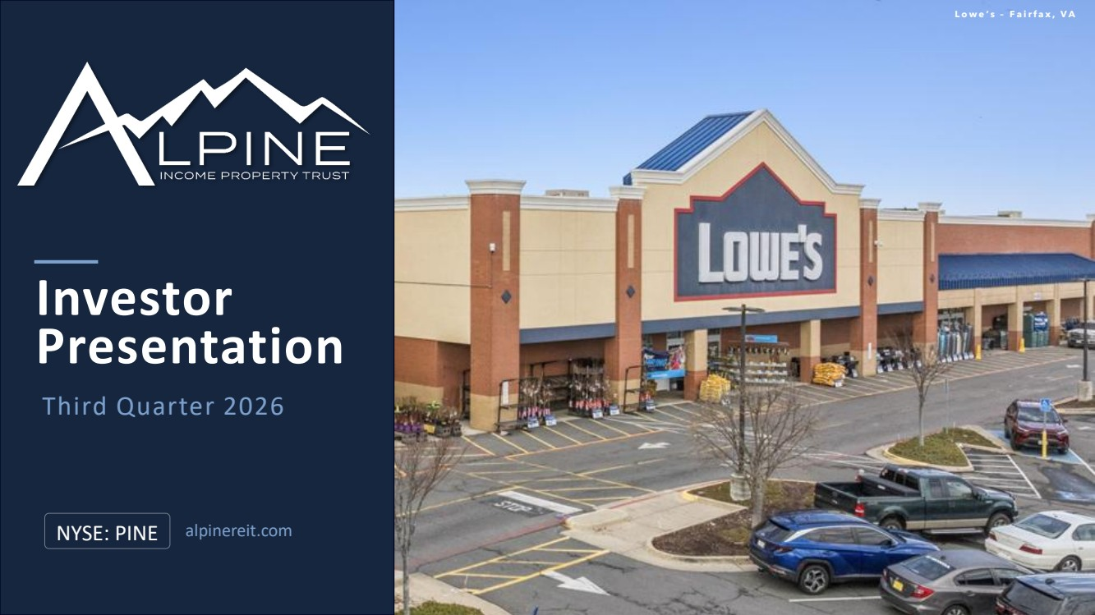 | Presentation NYSE: PINE Third Quarter 2026 Investor alpinereit.com L o w e ’ s – F a i r f a x , V A
 | 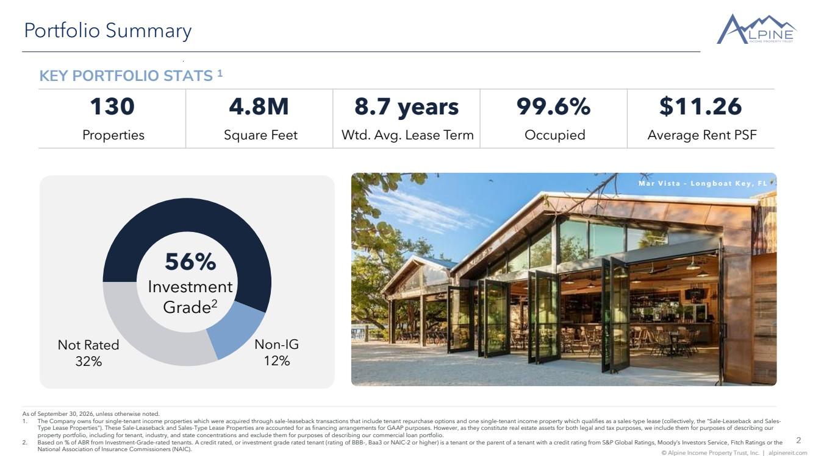 | 2 © Alpine Income Property Trust, Inc. | alpinereit.com Portfolio Summary 56% Investment Grade2 Non-IG 12% Not Rated 32% 2 © Alpine Income Property Trust, Inc. | alpinereit.com As of September 30, 2026, unless otherwise noted. 1. The Company owns four single-tenant income properties which were acquired through sale-leaseback transactions that include tenant repurchase options and one single-tenant income property which qualifies as a sales-type lease (collectively, the "Sale-Leaseback and Sales-Type Lease Properties"). These Sale-Leaseback and Sales-Type Lease Properties are accounted for as financing arrangements for GAAP purposes. However, as they constitute real estate assets for both legal and tax purposes, we include them for purposes of describing our property portfolio, including for tenant, industry, and state concentrations and exclude them for purposes of describing our commercial loan portfolio. 2. Based on % of ABR from Investment-Grade-rated tenants. A credit rated, or investment grade rated tenant (rating of BBB-, Baa3 or NAIC-2 or higher) is a tenant or the parent of a tenant with a credit rating from S&P Global Ratings, Moody’s Investors Service, Fitch Ratings or the National Association of Insurance Commissioners (NAIC). KEY PORTFOLIO STATS 1 M a r V i s t a – L o n g b o a t K e y , F L 130 4.8M 8.7 years 99.6% $11.26 Properties Square Feet Wtd. Avg. Lease Term Occupied Average Rent PSF
 | 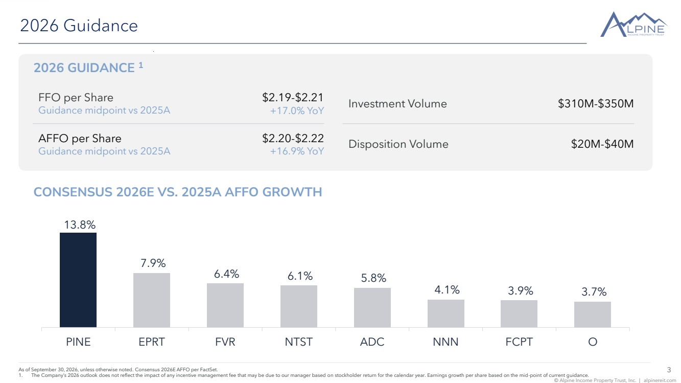 | 3 © Alpine Income Property Trust, Inc. | alpinereit.com 2026 GUIDANCE 1 2026 Guidance 3 © Alpine Income Property Trust, Inc. | alpinereit.com As of September 30, 2026, unless otherwise noted. Consensus 2026E AFFO per FactSet. 1. The Company’s 2026 outlook does not reflect the impact of any incentive management fee that may be due to our manager based on stockholder return for the calendar year. Earnings growth per share based on the mid-point of current guidance. FFO per Share Guidance midpoint vs 2025A $2.19-$2.21 +17.0% YoY AFFO per Share Guidance midpoint vs 2025A $2.20-$2.22 +16.9% YoY Investment Volume $310M-$350M Disposition Volume $20M-$40M CONSENSUS 2026E VS. 2025A AFFO GROWTH 13.8% 7.9% 6.4% 6.1% 5.8% 4.1% 3.9% 3.7% PINE EPRT FVR NTST ADC NNN FCPT O
 | 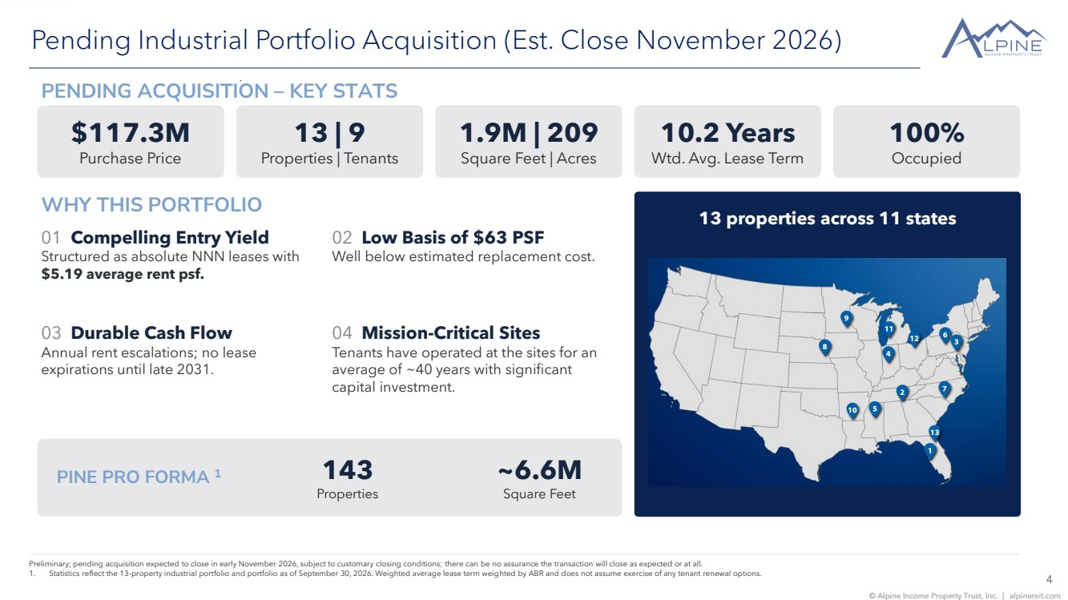 | 4 © Alpine Income Property Trust, Inc. | alpinereit.com Pending Industrial Portfolio Acquisition (Est. Close November 2026) Preliminary; pending acquisition expected to close in early November 2026, subject to customary closing conditions; there can be no assurance the transaction will close as expected or at all. 1. Statistics reflect the 13-property industrial portfolio and portfolio as of September 30, 2026. Weighted average lease term weighted by ABR and does not assume exercise of any tenant renewal options. PENDING ACQUISITION – KEY STATS $117.3M Purchase Price 13 | 9 Properties | Tenants 1.9M | 209 Square Feet | Acres 10.2 Years Wtd. Avg. Lease Term 100% Occupied WHY THIS PORTFOLIO 01 Compelling Entry Yield Structured as absolute NNN leases with $5.19 average rent psf. 02 Low Basis of $63 PSF Well below estimated replacement cost. 03 Durable Cash Flow Annual rent escalations; no lease expirations until late 2031. 04 Mission-Critical Sites Tenants have operated at the sites for an average of ~40 years with significant capital investment. 13 properties across 11 states PINE PRO FORMA 1 143 Properties ~6.6M Square Feet
 | 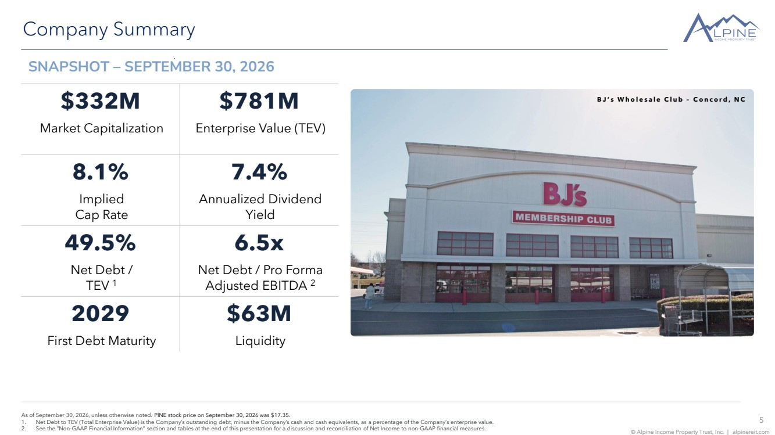 | 5 © Alpine Income Property Trust, Inc. | alpinereit.com Company Summary As of September 30, 2026, unless otherwise noted. PINE stock price on September 30, 2026 was $17.35. 1. Net Debt to TEV (Total Enterprise Value) is the Company’s outstanding debt, minus the Company’s cash and cash equivalents, as a percentage of the Company’s enterprise value. 2. See the “Non-GAAP Financial Information” section and tables at the end of this presentation for a discussion and reconciliation of Net Income to non-GAAP financial measures. $332M $781M Market Capitalization Enterprise Value (TEV) 8.1% 7.4% Implied Cap Rate Annualized Dividend Yield 49.5% 6.5x Net Debt / TEV 1 Net Debt / Pro Forma Adjusted EBITDA 2 2029 $63M First Debt Maturity Liquidity SNAPSHOT – SEPTEMBER 30, 2026 B J ’ s W h o l e s a l e C l u b – C o n c o r d , N C
 | 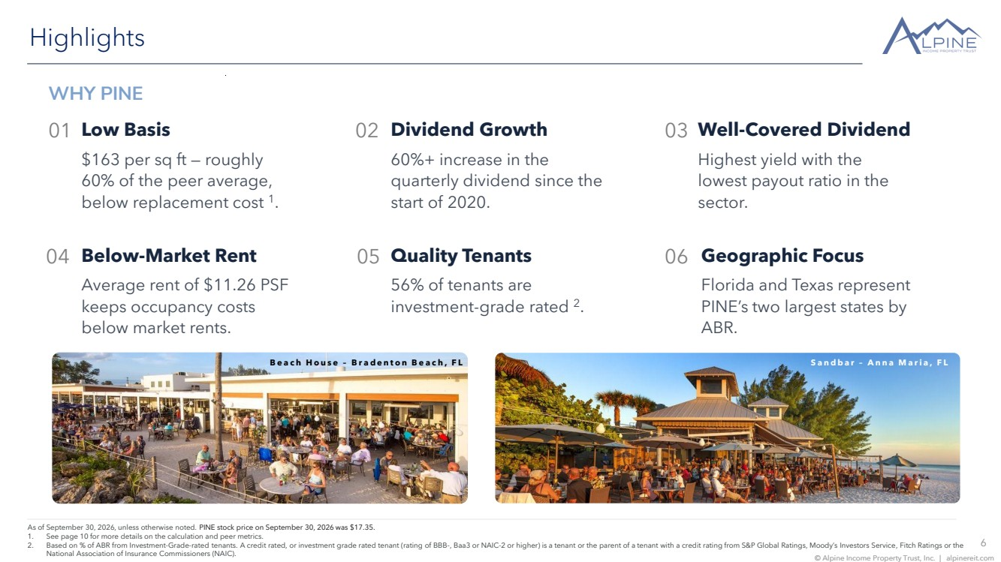 | 6 © Alpine Income Property Trust, Inc. | alpinereit.com Highlights As of September 30, 2026, unless otherwise noted. PINE stock price on September 30, 2026 was $17.35. 1. See page 10 for more details on the calculation and peer metrics. 2. Based on % of ABR from Investment-Grade-rated tenants. A credit rated, or investment grade rated tenant (rating of BBB-, Baa3 or NAIC-2 or higher) is a tenant or the parent of a tenant with a credit rating from S&P Global Ratings, Moody’s Investors Service, Fitch Ratings or the National Association of Insurance Commissioners (NAIC). WHY PINE 01 Low Basis $163 per sq ft — roughly 60% of the peer average, below replacement cost 1 . 02 Dividend Growth 60%+ increase in the quarterly dividend since the start of 2020. 03 Well-Covered Dividend Highest yield with the lowest payout ratio in the sector. 04 Below-Market Rent Average rent of $11.26 PSF keeps occupancy costs below market rents. Quality Tenants 56% of tenants are investment-grade rated 2 . 05 Geographic Focus Florida and Texas represent PINE’s two largest states by ABR. 06 B e a c h H o u s e – B r a d e n t o n B e a c h , F L S a n d b a r – A n n a M a r i a , F L
 | 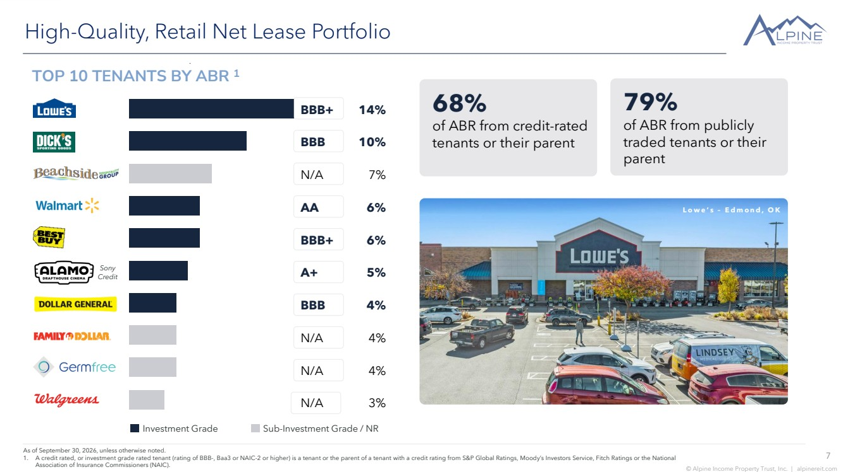 | 7 © Alpine Income Property Trust, Inc. | alpinereit.com High-Quality, Retail Net Lease Portfolio As of September 30, 2026, unless otherwise noted. 1. A credit rated, or investment grade rated tenant (rating of BBB-, Baa3 or NAIC-2 or higher) is a tenant or the parent of a tenant with a credit rating from S&P Global Ratings, Moody’s Investors Service, Fitch Ratings or the National Association of Insurance Commissioners (NAIC). Investment Grade Sub-Investment Grade / NR BBB+ 14% BBB 10% N/A 7% AA 6% BBB+ 6% A+ 5% BBB 4% N/A 4% N/A 4% N/A 3% Sony Credit OPERATIONAL TRANSPARENCY 69% of ABR comes from tenants or the parent of a tenant that are credit-rated L o w e ’ s – E d m o n d , O K TOP 10 TENANTS BY ABR 1 68% of ABR from credit-rated tenants or their parent 79% of ABR from publicly traded tenants or their parent
 | 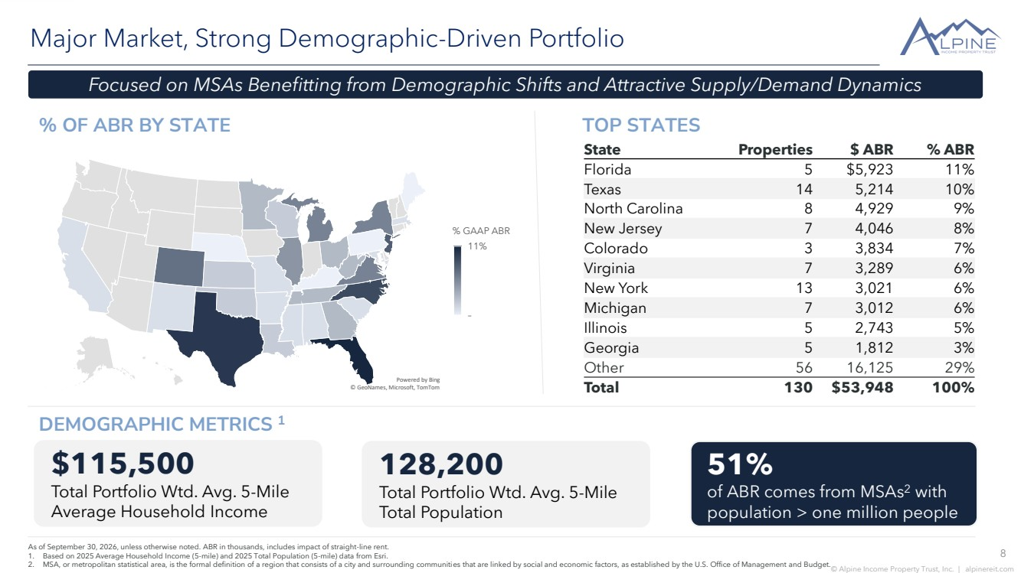 | 8 © Alpine Income Property Trust, Inc. | alpinereit.com % OF ABR BY STATE Major Market, Strong Demographic-Driven Portfolio As of September 30, 2026, unless otherwise noted. ABR in thousands, includes impact of straight-line rent. 1. Based on 2025 Average Household Income (5-mile) and 2025 Total Population (5-mile) data from Esri. 2. MSA, or metropolitan statistical area, is the formal definition of a region that consists of a city and surrounding communities that are linked by social and economic factors, as established by the U.S. Office of Management and Budget. State Properties $ ABR % ABR Florida 5 $5,923 11% Texas 14 5,214 10% North Carolina 8 4,929 9% New Jersey 7 4,046 8% Colorado 3 3,834 7% Virginia 7 3,289 6% New York 13 3,021 6% Michigan 7 3,012 6% Illinois 5 2,743 5% Georgia 5 1,812 3% Other 56 16,125 29% Total 130 $53,948 100% $115,500 Total Portfolio Wtd. Avg. 5-Mile Average Household Income 128,200 Total Portfolio Wtd. Avg. 5-Mile Total Population 51% of ABR comes from MSAs2 with population > one million people Focused on MSAs Benefitting from Demographic Shifts and Attractive Supply/Demand Dynamics DEMOGRAPHIC METRICS 1 TOP STATES © GeoNames, Microsoft, TomTom Powered by Bing – 11% % GAAP ABR
 | 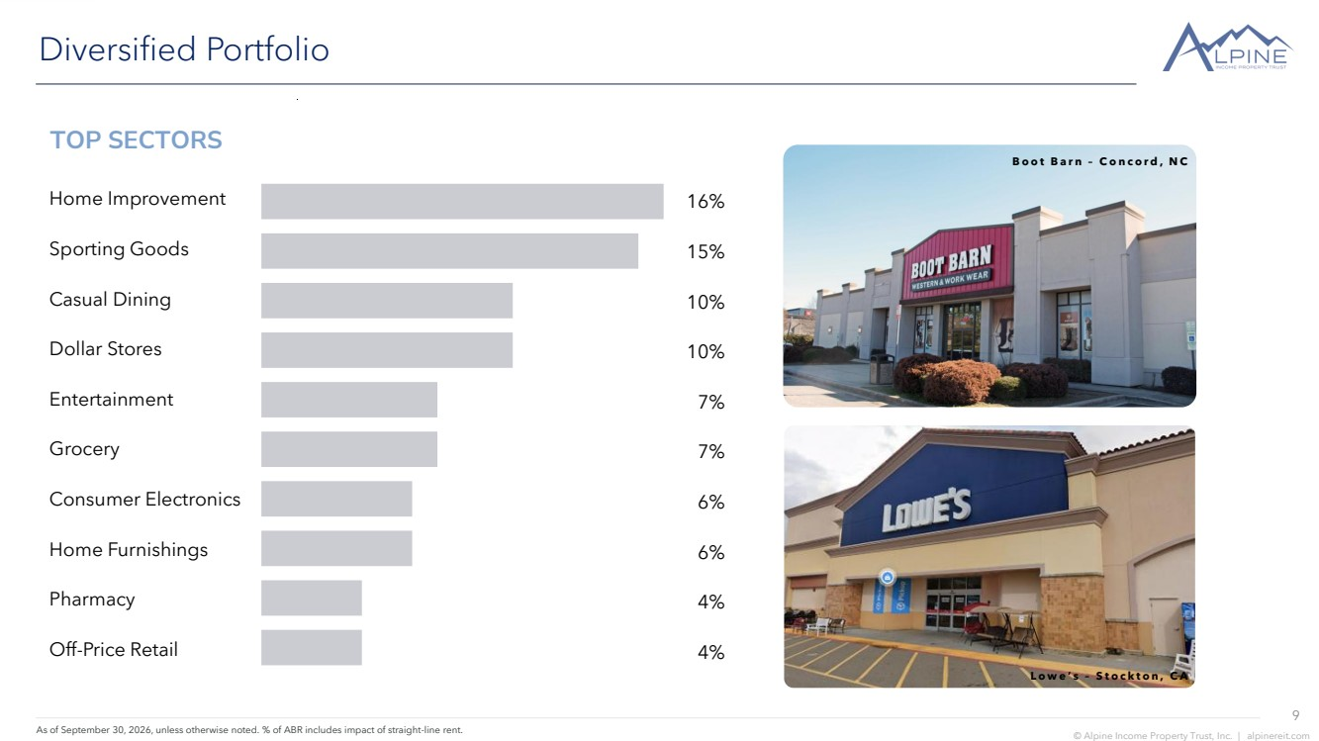 | 9 © Alpine Income Property Trust, Inc. | alpinereit.com Diversified Portfolio As of September 30, 2026, unless otherwise noted. % of ABR includes impact of straight-line rent. B o o t B a r n – C o n c o r d , N C L o w e ’ s – S t o c k t o n , C A TOP SECTORS 16% 15% 10% 10% 7% 7% 6% 6% 4% 4% Home Improvement Sporting Goods Casual Dining Dollar Stores Entertainment Grocery Consumer Electronics Home Furnishings Pharmacy Off-Price Retail
 | 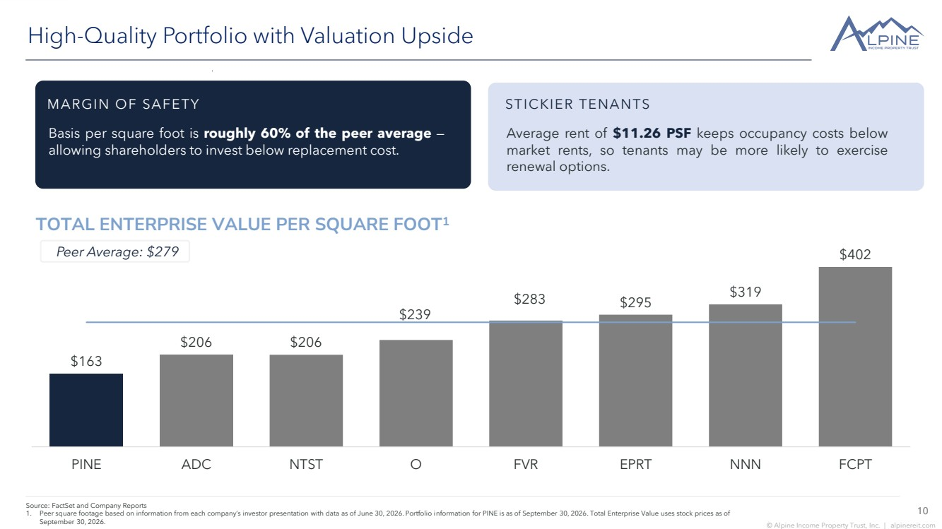 | 10 © Alpine Income Property Trust, Inc. | alpinereit.com TOTAL ENTERPRISE VALUE PER SQUARE FOOT1 High-Quality Portfolio with Valuation Upside Average rent of $11.26 PSF keeps occupancy costs below market rents, so tenants may be more likely to exercise renewal options. Source: FactSet and Company Reports 1. Peer square footage based on information from each company’s investor presentation with data as of June 30, 2026. Portfolio information for PINE is as of September 30, 2026. Total Enterprise Value uses stock prices as of September 30, 2026. 10 MARGIN OF SAFETY Basis per square foot is roughly 60% of the peer average — allowing shareholders to invest below replacement cost. STICKIER TENANTS Peer Average: $279 $402 $319 $283 $295 $239 $206 $206 $163 PINE ADC NTST O FVR EPRT NNN FCPT
 | 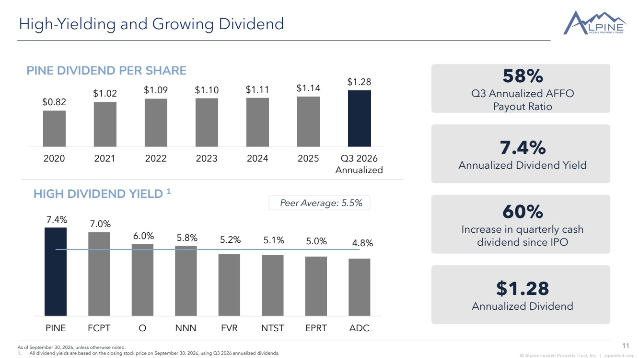 | 11 © Alpine Income Property Trust, Inc. | alpinereit.com 7.4% 7.0% 6.0% 5.8% 5.2% 5.1% 5.0% 4.8% PINE FCPT O NNN FVR NTST EPRT ADC $0.82 $1.02 $1.09 $1.10 $1.11 $1.14 $1.28 2020 2021 2022 2023 2024 2025 Q3 2026 Annualized As of September 30, 2026, unless otherwise noted. 1. All dividend yields are based on the closing stock price on September 30, 2026, using Q3 2026 annualized dividends. 11 High-Yielding and Growing Dividend 58% Q3 Annualized AFFO Payout Ratio 7.4% Annualized Dividend Yield 60% Increase in quarterly cash dividend since IPO $1.28 Annualized Dividend PINE DIVIDEND PER SHARE HIGH DIVIDEND YIELD 1 Peer Average: 5.5%
 | 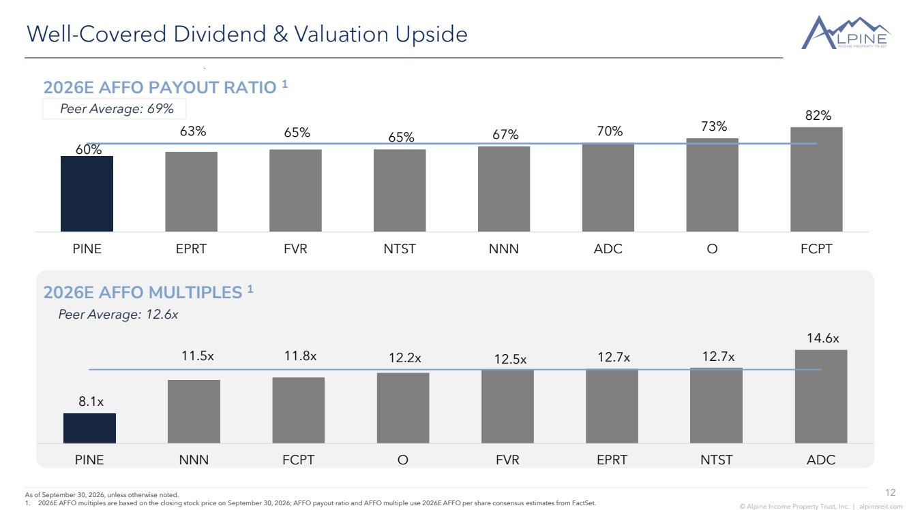 | 12 © Alpine Income Property Trust, Inc. | alpinereit.com 82% 73% 67% 70% 65% 63% 65% 60% PINE EPRT FVR NTST NNN ADC O FCPT Well-Covered Dividend & Valuation Upside As of September 30, 2026, unless otherwise noted. 1. 2026E AFFO multiples are based on the closing stock price on September 30, 2026; AFFO payout ratio and AFFO multiple use 2026E AFFO per share consensus estimates from FactSet. 2026E AFFO PAYOUT RATIO 1 2026E AFFO MULTIPLES 1 Peer Average: 69% Peer Average: 12.6x 14.6x 11.5x 11.8x 12.2x 12.5x 12.7x 12.7x 8.1x PINE NNN FCPT O FVR EPRT NTST ADC
 | 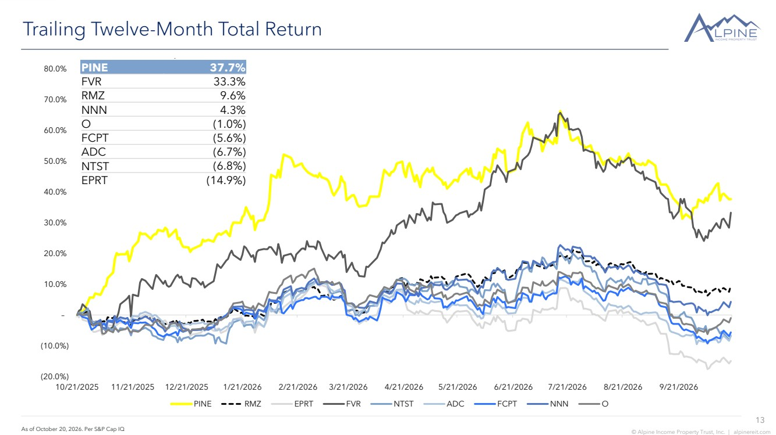 | 13 © Alpine Income Property Trust, Inc. | alpinereit.com Trailing Twelve-Month Total Return As of October 20, 2026. Per S&P Cap IQ (20.0%) (10.0%) – 10.0% 20.0% 30.0% 40.0% 50.0% 60.0% 70.0% 80.0% 10/21/2025 11/21/2025 12/21/2025 1/21/2026 2/21/2026 3/21/2026 4/21/2026 5/21/2026 6/21/2026 7/21/2026 8/21/2026 9/21/2026 PINE RMZ EPRT FVR NTST ADC FCPT NNN O PINE 37.7% FVR 33.3% RMZ 9.6% NNN 4.3% O (1.0%) FCPT (5.6%) ADC (6.7%) NTST (6.8%) EPRT (14.9%)
 | 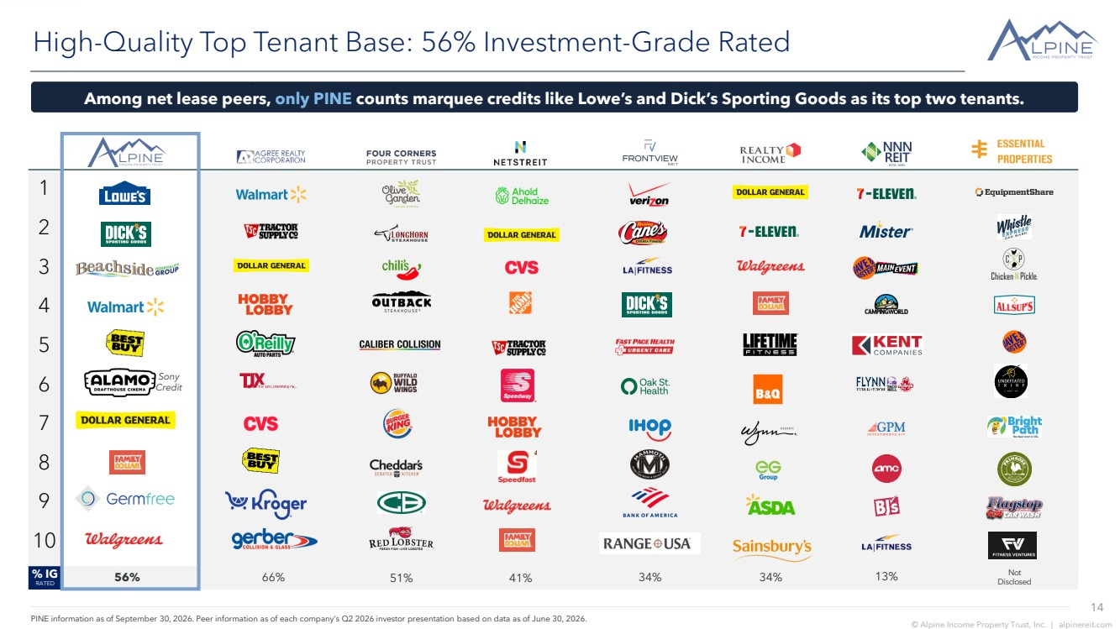 | 14 © Alpine Income Property Trust, Inc. | alpinereit.com 1 2 3 4 5 6 7 8 9 10 High-Quality Top Tenant Base: 56% Investment-Grade Rated % IG RATED PINE information as of September 30, 2026. Peer information as of each company’s Q2 2026 investor presentation based on data as of June 30, 2026. 51% 13% Among net lease peers, only PINE counts marquee credits like Lowe’s and Dick’s Sporting Goods as its top two tenants. 56% Sony Credit 66% 41% 34% 34% Not Disclosed
 | 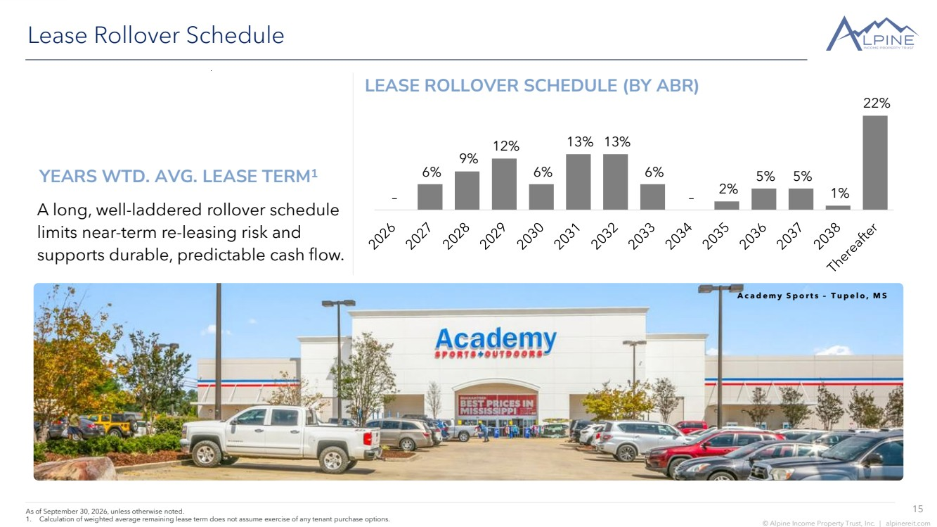 | 15 © Alpine Income Property Trust, Inc. | alpinereit.com Lease Rollover Schedule As of September 30, 2026, unless otherwise noted. 1. Calculation of weighted average remaining lease term does not assume exercise of any tenant purchase options. A long, well-laddered rollover schedule limits near-term re-leasing risk and supports durable, predictable cash flow. LEASE ROLLOVER SCHEDULE (BY ABR) A c a d e m y S p o r t s – T u p e l o , M S YEARS WTD. AVG. LEASE TERM1 – 6% 9% 12% 6% 13% 13% 6% – 2% 5% 5% 1% 22%
 | 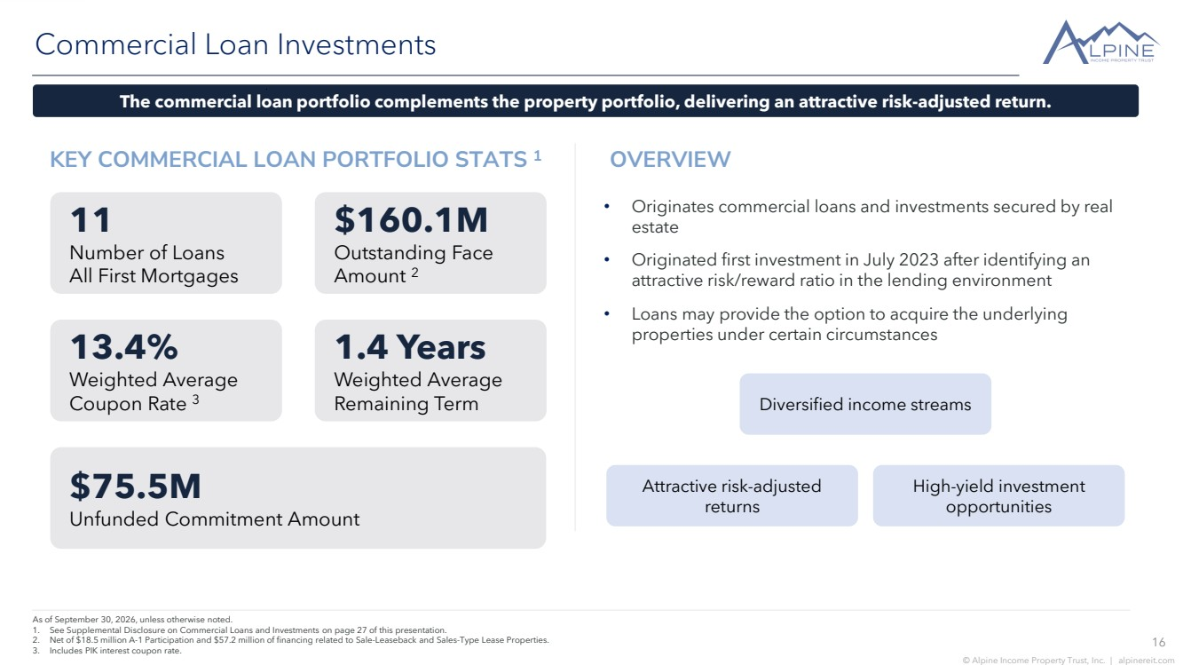 | 16 © Alpine Income Property Trust, Inc. | alpinereit.com KEY COMMERCIAL LOAN PORTFOLIO STATS 1 Commercial Loan Investments As of September 30, 2026, unless otherwise noted. 1. See Supplemental Disclosure on Commercial Loans and Investments on page 27 of this presentation. 2. Net of $18.5 million A-1 Participation and $57.2 million of financing related to Sale-Leaseback and Sales-Type Lease Properties. 3. Includes PIK interest coupon rate. • Originates commercial loans and investments secured by real estate • Originated first investment in July 2023 after identifying an attractive risk/reward ratio in the lending environment • Loans may provide the option to acquire the underlying properties under certain circumstances 11 Number of Loans All First Mortgages $160.1M Outstanding Face Amount 2 13.4% Weighted Average Coupon Rate 3 1.4 Years Weighted Average Remaining Term $75.5M Unfunded Commitment Amount Diversified income streams Attractive risk-adjusted returns The commercial loan portfolio complements the property portfolio, delivering an attractive risk-adjusted return. High-yield investment opportunities OVERVIEW
 | 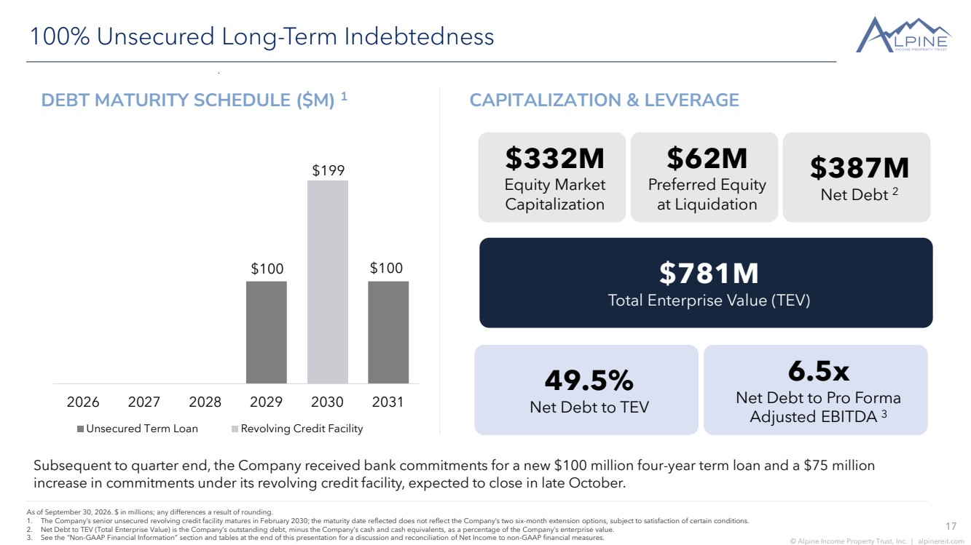 | 17 © Alpine Income Property Trust, Inc. | alpinereit.com $100 $100 $199 2026 2027 2028 2029 2030 2031 Unsecured Term Loan Revolving Credit Facility 100% Unsecured Long-Term Indebtedness As of September 30, 2026. $ in millions; any differences a result of rounding. 1. The Company’s senior unsecured revolving credit facility matures in February 2030; the maturity date reflected does not reflect the Company’s two six-month extension options, subject to satisfaction of certain conditions. 2. Net Debt to TEV (Total Enterprise Value) is the Company’s outstanding debt, minus the Company’s cash and cash equivalents, as a percentage of the Company’s enterprise value. 3. See the “Non-GAAP Financial Information” section and tables at the end of this presentation for a discussion and reconciliation of Net Income to non-GAAP financial measures. $332M Equity Market Capitalization $62M Preferred Equity at Liquidation $387M Net Debt 2 $781M Total Enterprise Value (TEV) 49.5% Net Debt to TEV 6.5x Net Debt to Pro Forma Adjusted EBITDA 3 DEBT MATURITY SCHEDULE ($M) 1 CAPITALIZATION & LEVERAGE Subsequent to quarter end, the Company received bank commitments for a new $100 million four-year term loan and a $75 million increase in commitments under its revolving credit facility, expected to close in late October.
 | 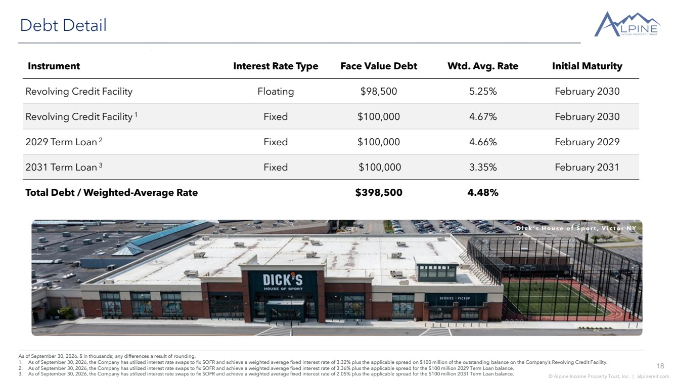 | 18 © Alpine Income Property Trust, Inc. | alpinereit.com Debt Detail As of September 30, 2026. $ in thousands; any differences a result of rounding. 1. As of September 30, 2026, the Company has utilized interest rate swaps to fix SOFR and achieve a weighted average fixed interest rate of 3.32% plus the applicable spread on $100 million of the outstanding balance on the Company’s Revolving Credit Facility. 2. As of September 30, 2026, the Company has utilized interest rate swaps to fix SOFR and achieve a weighted average fixed interest rate of 3.36% plus the applicable spread for the $100 million 2029 Term Loan balance. 3. As of September 30, 2026, the Company has utilized interest rate swaps to fix SOFR and achieve a weighted average fixed interest rate of 2.05% plus the applicable spread for the $100 million 2031 Term Loan balance. Instrument Interest Rate Type Face Value Debt Wtd. Avg. Rate Initial Maturity Revolving Credit Facility Floating $98,500 5.25% February 2030 Revolving Credit Facility 1 Fixed $100,000 4.67% February 2030 2029 Term Loan 2 Fixed $100,000 4.66% February 2029 2031 Term Loan 3 Fixed $100,000 3.35% February 2031 Total Debt / Weighted-Average Rate $398,500 4.48% D i c k ’ s H o u s e o f S p o r t , V i c t o r N Y
 | 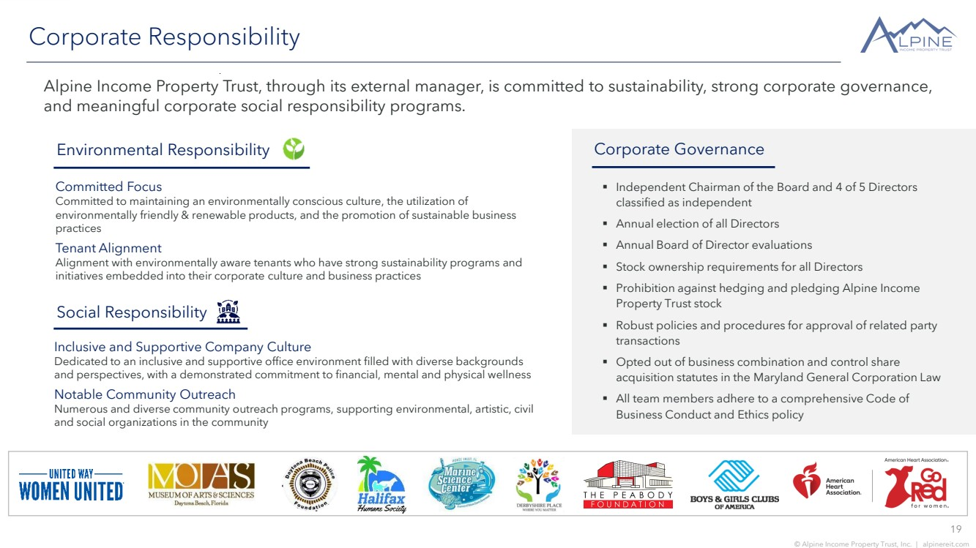 | 19 © Alpine Income Property Trust, Inc. | alpinereit.com Corporate Responsibility Alpine Income Property Trust, through its external manager, is committed to sustainability, strong corporate governance, and meaningful corporate social responsibility programs. Committed Focus Committed to maintaining an environmentally conscious culture, the utilization of environmentally friendly & renewable products, and the promotion of sustainable business practices Tenant Alignment Alignment with environmentally aware tenants who have strong sustainability programs and initiatives embedded into their corporate culture and business practices Social Responsibility Environmental Responsibility Corporate Governance ▪ Independent Chairman of the Board and 4 of 5 Directors classified as independent ▪ Annual election of all Directors ▪ Annual Board of Director evaluations ▪ Stock ownership requirements for all Directors ▪ Prohibition against hedging and pledging Alpine Income Property Trust stock ▪ Robust policies and procedures for approval of related party transactions ▪ Opted out of business combination and control share acquisition statutes in the Maryland General Corporation Law ▪ All team members adhere to a comprehensive Code of Business Conduct and Ethics policy Inclusive and Supportive Company Culture Dedicated to an inclusive and supportive office environment filled with diverse backgrounds and perspectives, with a demonstrated commitment to financial, mental and physical wellness Notable Community Outreach Numerous and diverse community outreach programs, supporting environmental, artistic, civil and social organizations in the community
 | 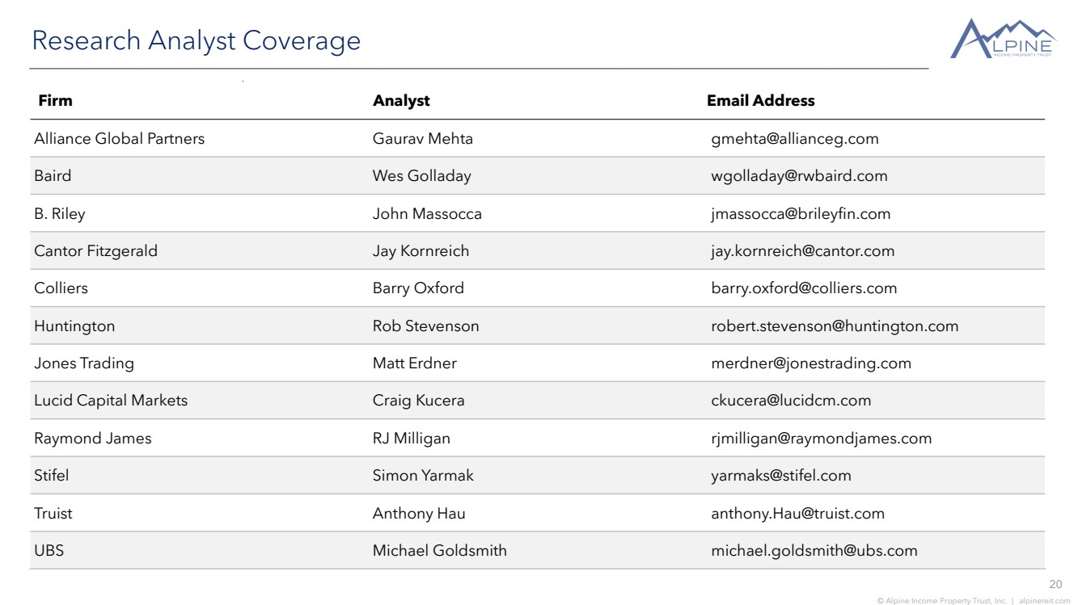 | 20 © Alpine Income Property Trust, Inc. | alpinereit.com Research Analyst Coverage Firm Analyst Email Address Alliance Global Partners Gaurav Mehta gmehta@allianceg.com Baird Wes Golladay wgolladay@rwbaird.com B. Riley John Massocca jmassocca@brileyfin.com Cantor Fitzgerald Jay Kornreich jay.kornreich@cantor.com Colliers Barry Oxford barry.oxford@colliers.com Huntington Rob Stevenson robert.stevenson@huntington.com Jones Trading Matt Erdner merdner@jonestrading.com Lucid Capital Markets Craig Kucera ckucera@lucidcm.com Raymond James RJ Milligan rjmilligan@raymondjames.com Stifel Simon Yarmak yarmaks@stifel.com Truist Anthony Hau anthony.Hau@truist.com UBS Michael Goldsmith michael.goldsmith@ubs.com
 | 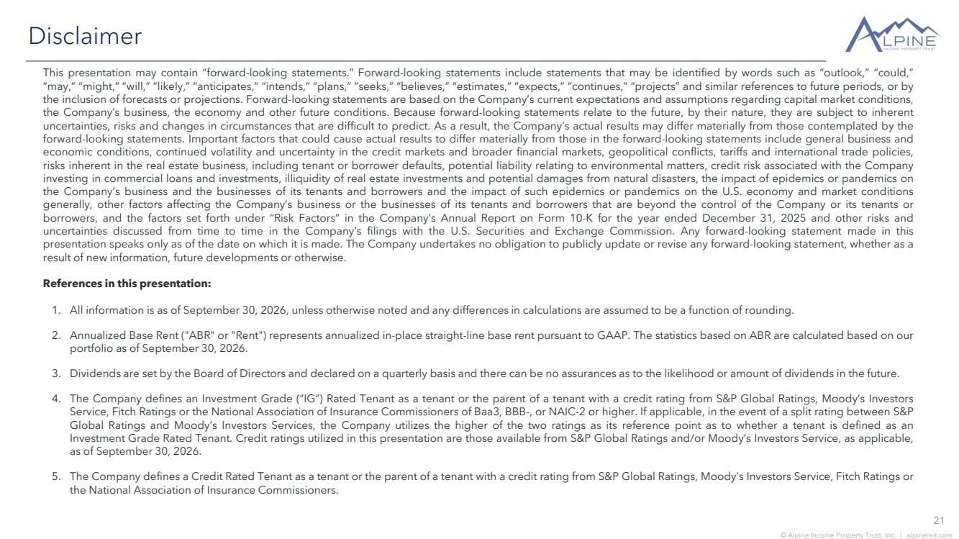 | 21 © Alpine Income Property Trust, Inc. | alpinereit.com Disclaimer This presentation may contain “forward-looking statements.” Forward-looking statements include statements that may be identified by words such as “outlook,” “could,” “may,” “might,” “will,” “likely,” “anticipates,” “intends,” “plans,” “seeks,” “believes,” “estimates,” “expects,” “continues,” “projects” and similar references to future periods, or by the inclusion of forecasts or projections. Forward-looking statements are based on the Company’s current expectations and assumptions regarding capital market conditions, the Company’s business, the economy and other future conditions. Because forward-looking statements relate to the future, by their nature, they are subject to inherent uncertainties, risks and changes in circumstances that are difficult to predict. As a result, the Company’s actual results may differ materially from those contemplated by the forward-looking statements. Important factors that could cause actual results to differ materially from those in the forward-looking statements include general business and economic conditions, continued volatility and uncertainty in the credit markets and broader financial markets, geopolitical conflicts, tariffs and international trade policies, risks inherent in the real estate business, including tenant or borrower defaults, potential liability relating to environmental matters, credit risk associated with the Company investing in commercial loans and investments, illiquidity of real estate investments and potential damages from natural disasters, the impact of epidemics or pandemics on the Company’s business and the businesses of its tenants and borrowers and the impact of such epidemics or pandemics on the U.S. economy and market conditions generally, other factors affecting the Company’s business or the businesses of its tenants and borrowers that are beyond the control of the Company or its tenants or borrowers, and the factors set forth under “Risk Factors” in the Company’s Annual Report on Form 10-K for the year ended December 31, 2025 and other risks and uncertainties discussed from time to time in the Company’s filings with the U.S. Securities and Exchange Commission. Any forward-looking statement made in this presentation speaks only as of the date on which it is made. The Company undertakes no obligation to publicly update or revise any forward-looking statement, whether as a result of new information, future developments or otherwise. References in this presentation: 1. All information is as of September 30, 2026, unless otherwise noted and any differences in calculations are assumed to be a function of rounding. 2. Annualized Base Rent ("ABR" or "Rent") represents annualized in-place straight-line base rent pursuant to GAAP. The statistics based on ABR are calculated based on our portfolio as of September 30, 2026. 3. Dividends are set by the Board of Directors and declared on a quarterly basis and there can be no assurances as to the likelihood or amount of dividends in the future. 4. The Company defines an Investment Grade (“IG”) Rated Tenant as a tenant or the parent of a tenant with a credit rating from S&P Global Ratings, Moody’s Investors Service, Fitch Ratings or the National Association of Insurance Commissioners of Baa3, BBB-, or NAIC-2 or higher. If applicable, in the event of a split rating between S&P Global Ratings and Moody’s Investors Services, the Company utilizes the higher of the two ratings as its reference point as to whether a tenant is defined as an Investment Grade Rated Tenant. Credit ratings utilized in this presentation are those available from S&P Global Ratings and/or Moody’s Investors Service, as applicable, as of September 30, 2026. 5. The Company defines a Credit Rated Tenant as a tenant or the parent of a tenant with a credit rating from S&P Global Ratings, Moody’s Investors Service, Fitch Ratings or the National Association of Insurance Commissioners.
 | 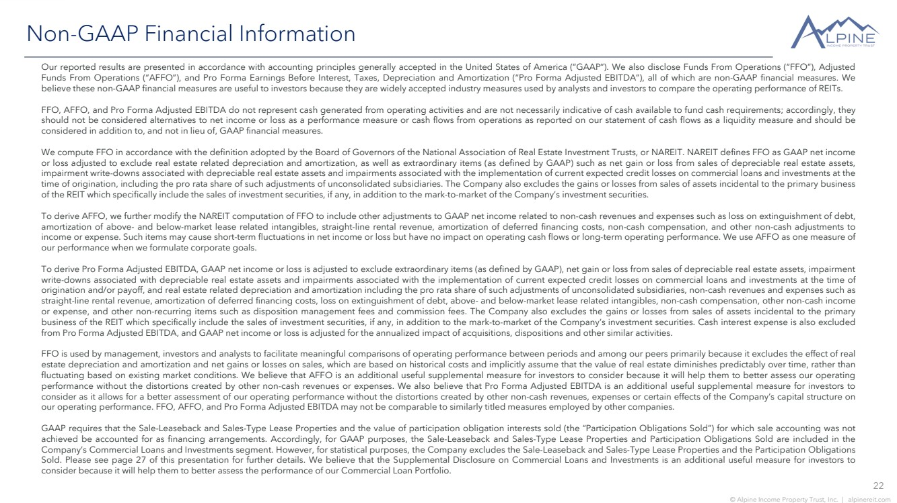 | 22 © Alpine Income Property Trust, Inc. | alpinereit.com Non-GAAP Financial Information Our reported results are presented in accordance with accounting principles generally accepted in the United States of America (“GAAP”). We also disclose Funds From Operations (“FFO”), Adjusted Funds From Operations (“AFFO”), and Pro Forma Earnings Before Interest, Taxes, Depreciation and Amortization (“Pro Forma Adjusted EBITDA”), all of which are non-GAAP financial measures. We believe these non-GAAP financial measures are useful to investors because they are widely accepted industry measures used by analysts and investors to compare the operating performance of REITs. FFO, AFFO, and Pro Forma Adjusted EBITDA do not represent cash generated from operating activities and are not necessarily indicative of cash available to fund cash requirements; accordingly, they should not be considered alternatives to net income or loss as a performance measure or cash flows from operations as reported on our statement of cash flows as a liquidity measure and should be considered in addition to, and not in lieu of, GAAP financial measures. We compute FFO in accordance with the definition adopted by the Board of Governors of the National Association of Real Estate Investment Trusts, or NAREIT. NAREIT defines FFO as GAAP net income or loss adjusted to exclude real estate related depreciation and amortization, as well as extraordinary items (as defined by GAAP) such as net gain or loss from sales of depreciable real estate assets, impairment write-downs associated with depreciable real estate assets and impairments associated with the implementation of current expected credit losses on commercial loans and investments at the time of origination, including the pro rata share of such adjustments of unconsolidated subsidiaries. The Company also excludes the gains or losses from sales of assets incidental to the primary business of the REIT which specifically include the sales of investment securities, if any, in addition to the mark-to-market of the Company’s investment securities. To derive AFFO, we further modify the NAREIT computation of FFO to include other adjustments to GAAP net income related to non-cash revenues and expenses such as loss on extinguishment of debt, amortization of above- and below-market lease related intangibles, straight-line rental revenue, amortization of deferred financing costs, non-cash compensation, and other non-cash adjustments to income or expense. Such items may cause short-term fluctuations in net income or loss but have no impact on operating cash flows or long-term operating performance. We use AFFO as one measure of our performance when we formulate corporate goals. To derive Pro Forma Adjusted EBITDA, GAAP net income or loss is adjusted to exclude extraordinary items (as defined by GAAP), net gain or loss from sales of depreciable real estate assets, impairment write-downs associated with depreciable real estate assets and impairments associated with the implementation of current expected credit losses on commercial loans and investments at the time of origination and/or payoff, and real estate related depreciation and amortization including the pro rata share of such adjustments of unconsolidated subsidiaries, non-cash revenues and expenses such as straight-line rental revenue, amortization of deferred financing costs, loss on extinguishment of debt, above- and below-market lease related intangibles, non-cash compensation, other non-cash income or expense, and other non-recurring items such as disposition management fees and commission fees. The Company also excludes the gains or losses from sales of assets incidental to the primary business of the REIT which specifically include the sales of investment securities, if any, in addition to the mark-to-market of the Company’s investment securities. Cash interest expense is also excluded from Pro Forma Adjusted EBITDA, and GAAP net income or loss is adjusted for the annualized impact of acquisitions, dispositions and other similar activities. FFO is used by management, investors and analysts to facilitate meaningful comparisons of operating performance between periods and among our peers primarily because it excludes the effect of real estate depreciation and amortization and net gains or losses on sales, which are based on historical costs and implicitly assume that the value of real estate diminishes predictably over time, rather than fluctuating based on existing market conditions. We believe that AFFO is an additional useful supplemental measure for investors to consider because it will help them to better assess our operating performance without the distortions created by other non-cash revenues or expenses. We also believe that Pro Forma Adjusted EBITDA is an additional useful supplemental measure for investors to consider as it allows for a better assessment of our operating performance without the distortions created by other non-cash revenues, expenses or certain effects of the Company’s capital structure on our operating performance. FFO, AFFO, and Pro Forma Adjusted EBITDA may not be comparable to similarly titled measures employed by other companies. GAAP requires that the Sale-Leaseback and Sales-Type Lease Properties and the value of participation obligation interests sold (the “Participation Obligations Sold”) for which sale accounting was not achieved be accounted for as financing arrangements. Accordingly, for GAAP purposes, the Sale-Leaseback and Sales-Type Lease Properties and Participation Obligations Sold are included in the Company’s Commercial Loans and Investments segment. However, for statistical purposes, the Company excludes the Sale-Leaseback and Sales-Type Lease Properties and the Participation Obligations Sold. Please see page 27 of this presentation for further details. We believe that the Supplemental Disclosure on Commercial Loans and Investments is an additional useful measure for investors to consider because it will help them to better assess the performance of our Commercial Loan Portfolio.
 | 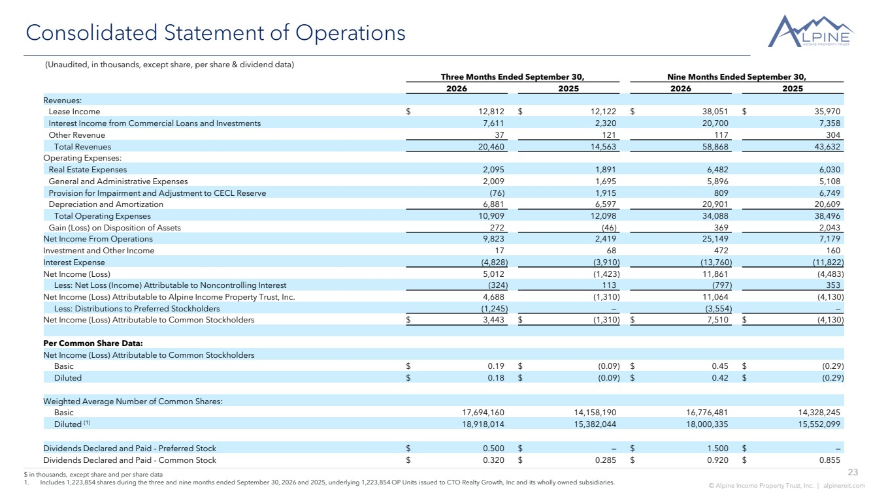 | 23 © Alpine Income Property Trust, Inc. | alpinereit.com Consolidated Statement of Operations $ in thousands, except share and per share data 1. Includes 1,223,854 shares during the three and nine months ended September 30, 2026 and 2025, underlying 1,223,854 OP Units issued to CTO Realty Growth, Inc and its wholly owned subsidiaries. (Unaudited, in thousands, except share, per share & dividend data) Three Months Ended September 30, Nine Months Ended September 30, 2026 2025 2026 2025 Revenues: Lease Income $ 12,812 $ 12,122 $ 38,051 $ 35,970 Interest Income from Commercial Loans and Investments 7,611 2,320 20,700 7,358 Other Revenue 37 121 117 304 Total Revenues 20,460 14,563 58,868 43,632 Operating Expenses: Real Estate Expenses 2,095 1,891 6,482 6,030 General and Administrative Expenses 2,009 1,695 5,896 5,108 Provision for Impairment and Adjustment to CECL Reserve (76) 1,915 809 6,749 Depreciation and Amortization 6,881 6,597 20,901 20,609 Total Operating Expenses 10,909 12,098 34,088 38,496 Gain (Loss) on Disposition of Assets 272 (46) 369 2,043 Net Income From Operations 9,823 2,419 25,149 7,179 Investment and Other Income 17 68 472 160 Interest Expense (4,828) (3,910) (13,760) (11,822) Net Income (Loss) 5,012 (1,423) 11,861 (4,483) Less: Net Loss (Income) Attributable to Noncontrolling Interest (324) 113 (797) 353 Net Income (Loss) Attributable to Alpine Income Property Trust, Inc. 4,688 (1,310) 11,064 (4,130) Less: Distributions to Preferred Stockholders (1,245) — (3,554) — Net Income (Loss) Attributable to Common Stockholders $ 3,443 $ (1,310) $ 7,510 $ (4,130) Per Common Share Data: Net Income (Loss) Attributable to Common Stockholders Basic $ 0.19 $ (0.09) $ 0.45 $ (0.29) Diluted $ 0.18 $ (0.09) $ 0.42 $ (0.29) Weighted Average Number of Common Shares: Basic 17,694,160 14,158,190 16,776,481 14,328,245 Diluted (1) 18,918,014 15,382,044 18,000,335 15,552,099 Dividends Declared and Paid - Preferred Stock $ 0.500 $ — $ 1.500 $ — Dividends Declared and Paid - Common Stock $ 0.320 $ 0.285 $ 0.920 $ 0.855
 | 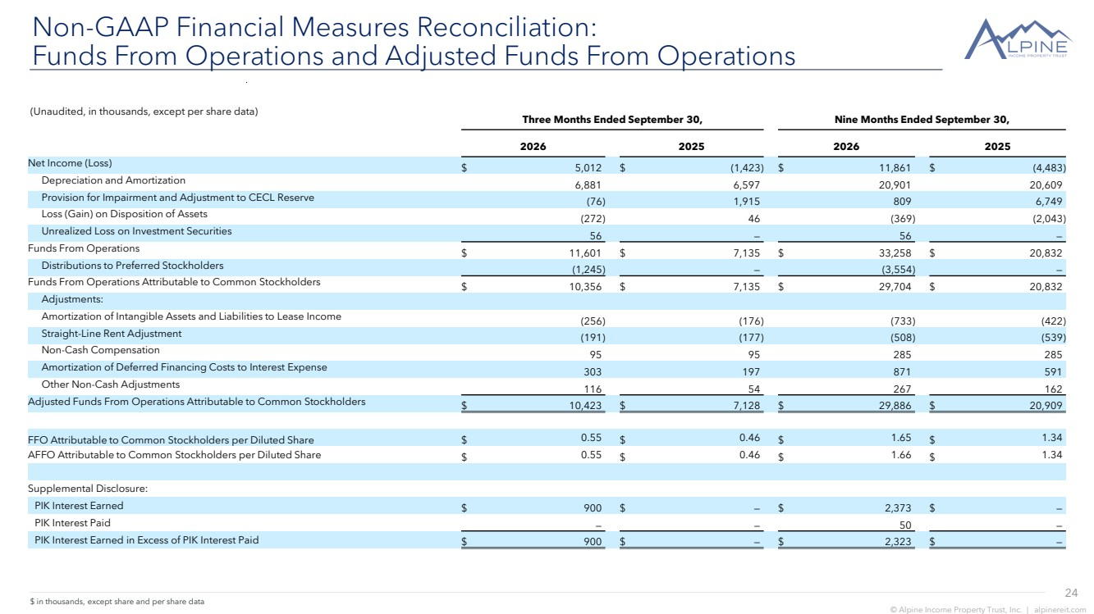 | 24 © Alpine Income Property Trust, Inc. | alpinereit.com Non-GAAP Financial Measures Reconciliation: Funds From Operations and Adjusted Funds From Operations $ in thousands, except share and per share data (Unaudited, in thousands, except per share data) Three Months Ended September 30, Nine Months Ended September 30, 2026 2025 2026 2025 Net Income (Loss) $ 5,012 $ (1,423) $ 11,861 $ (4,483) Depreciation and Amortization 6,881 6,597 20,901 20,609 Provision for Impairment and Adjustment to CECL Reserve (76) 1,915 809 6,749 Loss (Gain) on Disposition of Assets (272) 46 (369) (2,043) Unrealized Loss on Investment Securities 56 — 56 — Funds From Operations $ 11,601 $ 7,135 $ 33,258 $ 20,832 Distributions to Preferred Stockholders (1,245) — (3,554) — Funds From Operations Attributable to Common Stockholders $ 10,356 $ 7,135 $ 29,704 $ 20,832 Adjustments: Amortization of Intangible Assets and Liabilities to Lease Income (256) (176) (733) (422) Straight-Line Rent Adjustment (191) (177) (508) (539) Non-Cash Compensation 95 95 285 285 Amortization of Deferred Financing Costs to Interest Expense 303 197 871 591 Other Non-Cash Adjustments 116 54 267 162 Adjusted Funds From Operations Attributable to Common Stockholders $ 10,423 $ 7,128 $ 29,886 $ 20,909 FFO Attributable to Common Stockholders per Diluted Share $ 0.55 $ 0.46 $ 1.65 $ 1.34 AFFO Attributable to Common Stockholders per Diluted Share $ 0.55 $ 0.46 $ 1.66 $ 1.34 Supplemental Disclosure: PIK Interest Earned $ 900 $ — $ 2,373 $ — PIK Interest Paid — — 50 — PIK Interest Earned in Excess of PIK Interest Paid $ 900 $ — $ 2,323 $ —
 | 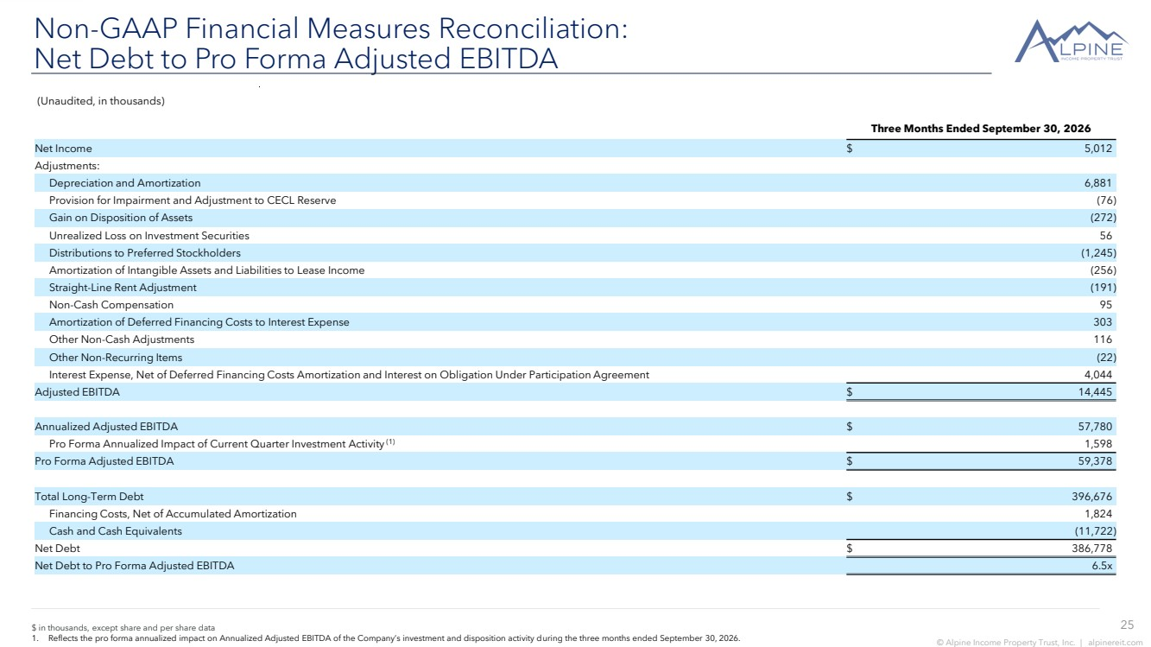 | 25 © Alpine Income Property Trust, Inc. | alpinereit.com $ in thousands, except share and per share data 1. Reflects the pro forma annualized impact on Annualized Adjusted EBITDA of the Company’s investment and disposition activity during the three months ended September 30, 2026. Non-GAAP Financial Measures Reconciliation: Net Debt to Pro Forma Adjusted EBITDA (Unaudited, in thousands) Three Months Ended September 30, 2026 Net Income $ 5,012 Adjustments: Depreciation and Amortization 6,881 Provision for Impairment and Adjustment to CECL Reserve (76) Gain on Disposition of Assets (272) Unrealized Loss on Investment Securities 56 Distributions to Preferred Stockholders (1,245) Amortization of Intangible Assets and Liabilities to Lease Income (256) Straight-Line Rent Adjustment (191) Non-Cash Compensation 95 Amortization of Deferred Financing Costs to Interest Expense 303 Other Non-Cash Adjustments 116 Other Non-Recurring Items (22) Interest Expense, Net of Deferred Financing Costs Amortization and Interest on Obligation Under Participation Agreement 4,044 Adjusted EBITDA $ 14,445 Annualized Adjusted EBITDA $ 57,780 Pro Forma Annualized Impact of Current Quarter Investment Activity (1) 1,598 Pro Forma Adjusted EBITDA $ 59,378 Total Long-Term Debt $ 396,676 Financing Costs, Net of Accumulated Amortization 1,824 Cash and Cash Equivalents (11,722) Net Debt $ 386,778 Net Debt to Pro Forma Adjusted EBITDA 6.5x
 | 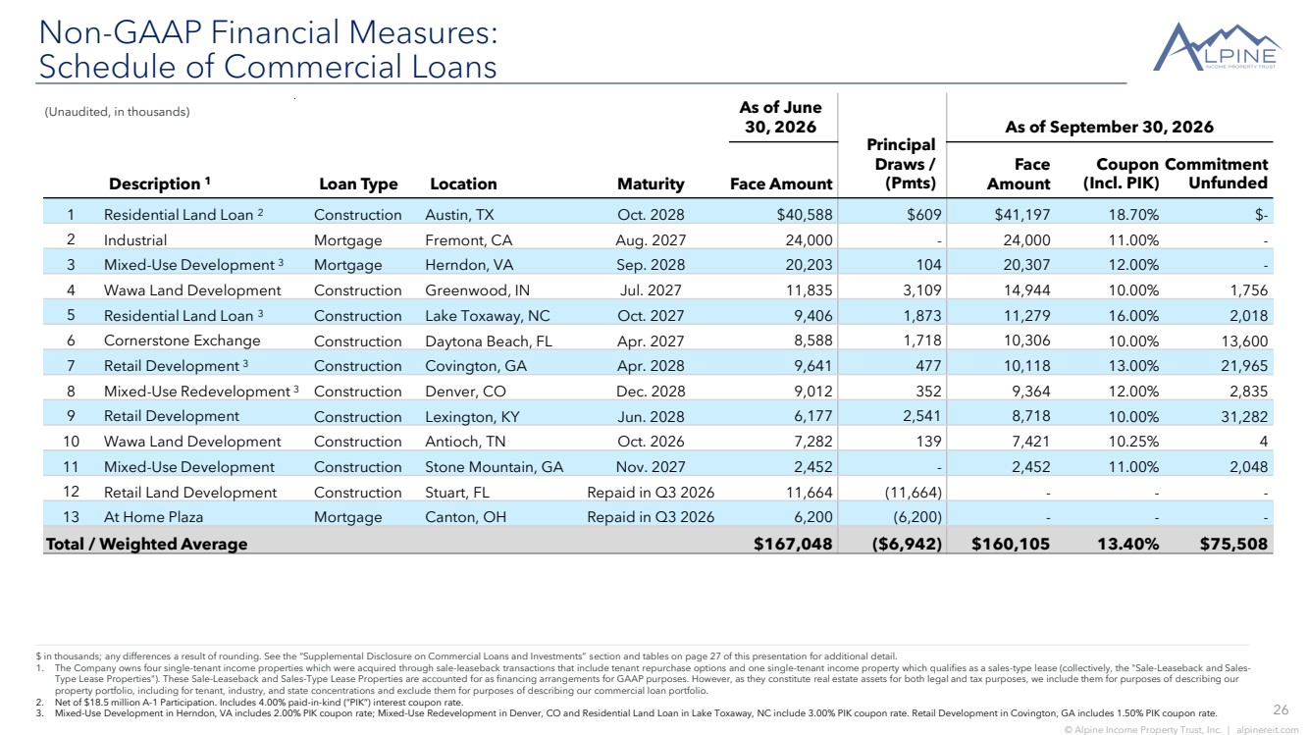 | 26 © Alpine Income Property Trust, Inc. | alpinereit.com Non-GAAP Financial Measures: Schedule of Commercial Loans $ in thousands; any differences a result of rounding. See the “Supplemental Disclosure on Commercial Loans and Investments” section and tables on page 27 of this presentation for additional detail. 1. The Company owns four single-tenant income properties which were acquired through sale-leaseback transactions that include tenant repurchase options and one single-tenant income property which qualifies as a sales-type lease (collectively, the "Sale-Leaseback and Sales-Type Lease Properties"). These Sale-Leaseback and Sales-Type Lease Properties are accounted for as financing arrangements for GAAP purposes. However, as they constitute real estate assets for both legal and tax purposes, we include them for purposes of describing our property portfolio, including for tenant, industry, and state concentrations and exclude them for purposes of describing our commercial loan portfolio. 2. Net of $18.5 million A-1 Participation. Includes 4.00% paid-in-kind (“PIK”) interest coupon rate. 3. Mixed-Use Development in Herndon, VA includes 2.00% PIK coupon rate; Mixed-Use Redevelopment in Denver, CO and Residential Land Loan in Lake Toxaway, NC include 3.00% PIK coupon rate. Retail Development in Covington, GA includes 1.50% PIK coupon rate. Description 1 Loan Type Location Maturity As of June 30, 2026 Principal Draws / (Pmts) As of September 30, 2026 Face Amount Face Amount Coupon (Incl. PIK) Commitment Unfunded 1 Residential Land Loan 2 Construction Austin, TX Oct. 2028 $40,588 $609 $41,197 18.70% $- 2 Industrial Mortgage Fremont, CA Aug. 2027 24,000 - 24,000 11.00% - 3 Mixed-Use Development 3 Mortgage Herndon, VA Sep. 2028 20,203 104 20,307 12.00% - 4 Wawa Land Development Construction Greenwood, IN Jul. 2027 11,835 3,109 14,944 10.00% 1,756 5 Residential Land Loan 3 Construction Lake Toxaway, NC Oct. 2027 9,406 1,873 11,279 16.00% 2,018 6 Cornerstone Exchange Construction Daytona Beach, FL Apr. 2027 8,588 1,718 10,306 10.00% 13,600 7 Retail Development 3 Construction Covington, GA Apr. 2028 9,641 477 10,118 13.00% 21,965 8 Mixed-Use Redevelopment 3 Construction Denver, CO Dec. 2028 9,012 352 9,364 12.00% 2,835 9 Retail Development Construction Lexington, KY Jun. 2028 6,177 2,541 8,718 10.00% 31,282 10 Wawa Land Development Construction Antioch, TN Oct. 2026 7,282 139 7,421 10.25% 4 11 Mixed-Use Development Construction Stone Mountain, GA Nov. 2027 2,452 - 2,452 11.00% 2,048 12 Retail Land Development Construction Stuart, FL Repaid in Q3 2026 11,664 (11,664) - - - 13 At Home Plaza Mortgage Canton, OH Repaid in Q3 2026 6,200 (6,200) - - - Total / Weighted Average $167,048 ($6,942) $160,105 13.40% $75,508 (Unaudited, in thousands)
 | 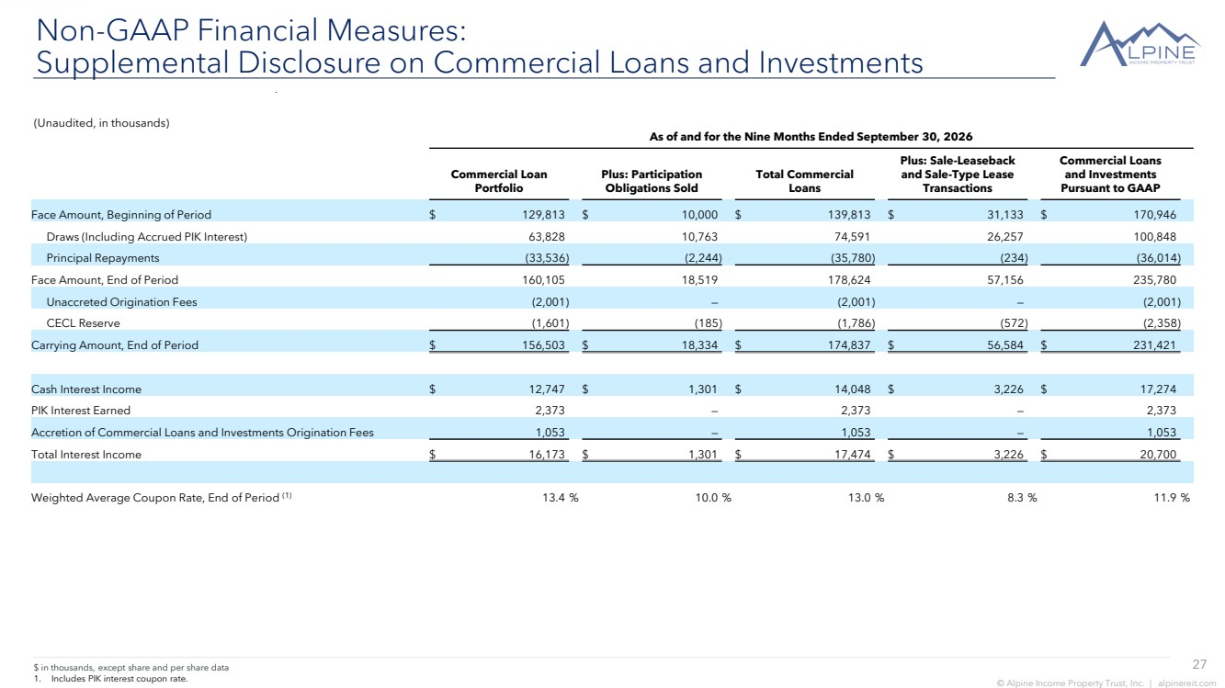 | 27 © Alpine Income Property Trust, Inc. | alpinereit.com $ in thousands, except share and per share data 1. Includes PIK interest coupon rate. Non-GAAP Financial Measures: Supplemental Disclosure on Commercial Loans and Investments (Unaudited, in thousands) As of and for the Nine Months Ended September 30, 2026 Commercial Loan Portfolio Plus: Participation Obligations Sold Total Commercial Loans Plus: Sale-Leaseback and Sale-Type Lease Transactions Commercial Loans and Investments Pursuant to GAAP Face Amount, Beginning of Period $ 129,813 $ 10,000 $ 139,813 $ 31,133 $ 170,946 Draws (Including Accrued PIK Interest) 63,828 10,763 74,591 26,257 100,848 Principal Repayments (33,536) (2,244) (35,780) (234) (36,014) Face Amount, End of Period 160,105 18,519 178,624 57,156 235,780 Unaccreted Origination Fees (2,001) — (2,001) — (2,001) CECL Reserve (1,601) (185) (1,786) (572) (2,358) Carrying Amount, End of Period $ 156,503 $ 18,334 $ 174,837 $ 56,584 $ 231,421 Cash Interest Income $ 12,747 $ 1,301 $ 14,048 $ 3,226 $ 17,274 PIK Interest Earned 2,373 — 2,373 — 2,373 Accretion of Commercial Loans and Investments Origination Fees 1,053 — 1,053 — 1,053 Total Interest Income $ 16,173 $ 1,301 $ 17,474 $ 3,226 $ 20,700 Weighted Average Coupon Rate, End of Period (1) 13.4 % 10.0 % 13.0 % 8.3 % 11.9 %
 |  | INVESTOR INQUIRIES ir@alpinereit.com NYSE: PINE

